
Visualization:

Chopping Up Plasmids

URL: http://mathbench.umd.edu/modules/visualization_plasmids/page01.htm

Note: All printer-friendly versions of the modules use an amazing new interactive technique called “cover up the answers”. You know what to do…

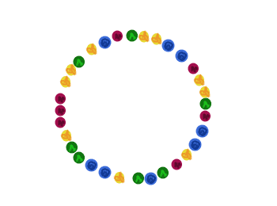
Three thieves and a beaded necklace
Once upon a time… there were 3 thieves. They got to arguing about how to divide up their booty – a single long necklace made of four different kinds of beads. Not being particularly smart, they could not figure out how to divide it up evenly. Finally they agreed simply to cut it apart every time there were two blue beads in a row.
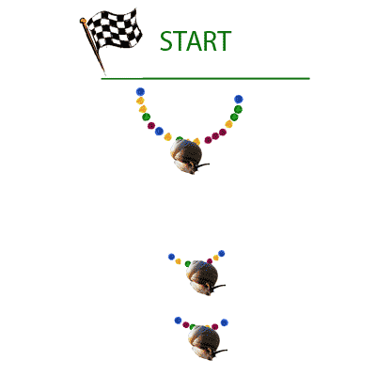
Since this happened exactly three times, the result was that the necklace got broken into three pieces. But were the pieces all the same size? Not being very smart, they couldn’t figure this out, until a passing pickpocket suggested they could attach each piece to a snail, put all three snails on a starting line, and see which snail went the farthest – that snail obviously had the shortest piece:

So that’s what the three thieves did, and they found that (of course) the pieces of the necklace were not the same length. At this point the thieves were tired of new and creative solutions and resorted to their usual method, a fistfight, while the pickpocket walked off with all three snails.
What is the moral of this thinly-disguised tale? Hopefully you’ve already read about plasmids, restriction enzymes, and gel electrophoresis. If not, go do that now…

... and its moral
OK, so here are some parallels:
Beaded Necklace: Like a beaded necklace, each plasmid is a circular piece of DNA, made of a 4 bases in a non-predictable pattern.
The Thieves: The thieves chopped up the necklace; likewise, restriction enzymes chop, or restrict, a plasmid.
Two Blue Beads: The thieves chopped every time they saw a certain pattern of beads; likewise, restriction enzymes recognize certain sequences of bases, called a restriction site, although these sequences are a generally 4 to 8 bases in length, not just 2.
The Length of the Pieces: One way to learn about the plasmid and its fragments, is to find out how long those fragments are. Although scientists are smarter than thieves, DNA itself is too small to see – so you can’t simply count the number of bases in a fragment, which leads to …
The snail race: in order to determine the length of the fragments, scientists use gel electrophoresis. Bottom line in electrophoresis: small molecules move faster, big molecules move slower, so by seeing where the fragments end up after a short period of time, you can guess how big they are.
Before we go on to the plasmid, check your understanding:
- A connected circle with 5 recognition sites would get broken into…
5 pieces
- A linear strand with 5 recognition sites would get broken into …
6 pieces
- If a connected circle with 3 red recognition sites and 5 blue recognition sites is broken at the red sites ONLY, how many fragments will result?
3
- If the same connected circle is broken at both red and blue sites?
8

A real plasmid
OK, so let’s talk plasmids. An average plasmid may be several thousand base pairs in length. So, with apologies, I will not actually be illustrating each base pair (bp) individually. Instead, I’ll just show you where base pair 0 is, and how many bp there are total.
The recognition site is also rather more complicated, so rather than write in all the bases, I’ll just show you with a line that is labeled A, for restriction enzyme site A.
Here’s an example:
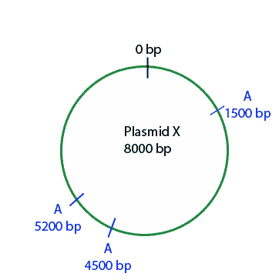
If we use restriction enzyme A on this plasmid, how many pieces should we get?
Answer: 3

How big will the shorter 2 pieces be?
- One piece goes from base pair 1500 to base pair 4500
- You can find the distance between 2 points by subtracting their locations

Answer: 700 base pairs and 3000 base pairs

How big will the longest piece be?
- this piece goes from 5200, up past 0, and around to 1500 base pairs
- from 5200 to 8000 is 3800 base pairs

Answer: 5300 base pairs (NOT 3800 – read the hints!)

The online version of this module contains an interactive applet which allows you to watch a virtual gel being run. To find this applet go to: http://mathbench.umd.edu/modules/visualization_plasmids/page03.htm | 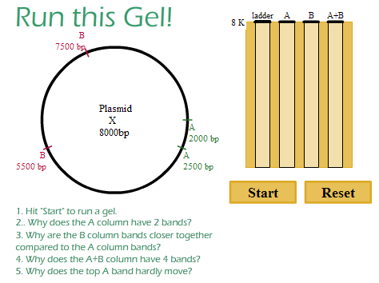

Practice with restriction sites
The online version of this module contains an interactive applet which allows you to predict what the gel will look like, given the map of the plasmid. To find this applet go to: http://mathbench.umd.edu/modules/visualization_plasmids/page04.htm | 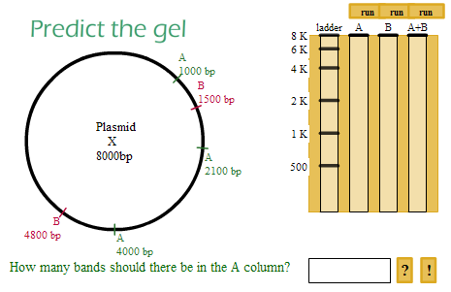
As you use more enzymes, you get more pieces, but those pieces are generally shorter. Translated into gel-speak, that means lanes with more enzymes have more bands, and they’re clustered closed to the end (rather than beginning) of the lane.

What's wrong with these gels?
Some mixed up students have recorded their gels incorrectly in their labbooks. They should be suspicious of each of the drawings below. Can you tell them why? (This is really a logical exercise, not a math exercise, which is why I didn’t put any numbers in. You can assume there are no odd conditions like overlapping bands in the same lane, or accidental breakage of the DNA into extra fragments).
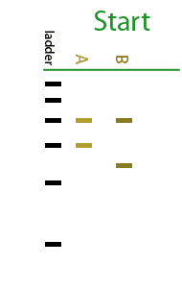 | - do the 2 lanes add up to the same total length of DNA?  Answer: The "top" fragment in each lane is the same size, but the bottom fragment is shorter in B, so the two lanes have different total lengths of DNA.

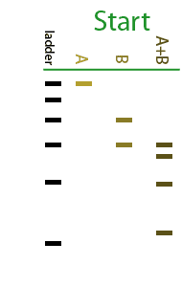 | - How many fragments are in each lane?  Answer: A has 1 fragment and B has 2. That means A cuts the plasmid once, and B cuts it twice. Lane (A+B) should have three fragments, but instead it has four.

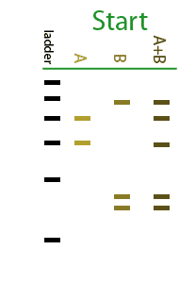 | - Do the 3 lanes each have the same total length of DNA?  Answer: Lane (A+B) has the exact same fragments found in Lane A, as well as the same fragments found in Lane B. This can't happen -- the total DNA in lane (A+B) is twice as long as in either of the other lanes.

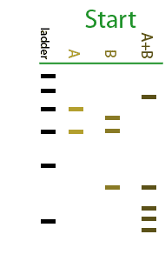 | - Look at the longest fragment in each lane.  Answer: Lane (A+B) has a fragment which is LONGER than any found in Lane A or Lane B. This is not possible, since A+B will cut the plasmid as small or smaller than either A or B alone.

Playing with plasmids
The online version of this module contains several interactive applets which allow you to:
build your own plasmid, and then run the gel to see what it looks like. | 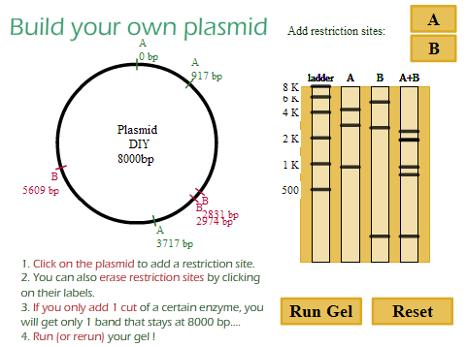
find the missing restriction site in plasmid given the gel. | 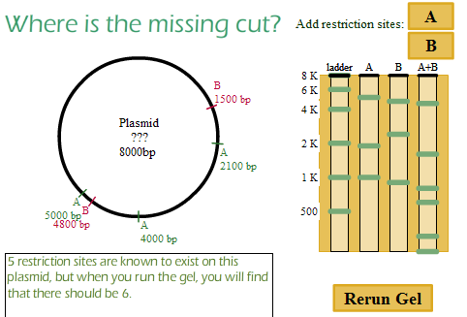
figure out what plasmid could produce the given gel? | 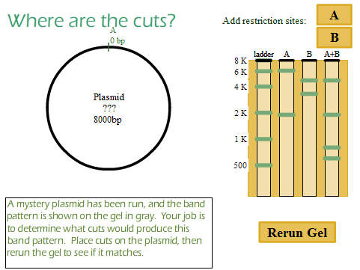

Other weirdnesses
Occasionally you may see other artefacts in the gel electrophoresis process -- extra bands that don't correspond to any of the fragments. Here's how that can happen:
- If only one strand of the double-helix gets cut, we say the circle has been "nicked". Then it loses it's ability to coil and becomes limp. This big, floppy mess of DNA has a hard time moving through the gel, so it appears to be a very large fragment (even larger than the plasmid itself).
- If the circle only gets cut at one restriction site (rather than at all restriction sites), the result is a linear piece of DNA that has the same length as the total plasmid. This big strand of DNA has to be oriented pointy-side first to get through the gel, so naturally it doesn't get very far.
- If a plasmid supercoils, it compacts itself and can move very quickly through the gel. Thus, even though it has not been cut, it appears to be a very small fragment.

Review
Plasmids are pieces of DNA that contain recognition sites where restriction enzymes cut plasmid.
To separate and find out the length of fragments cut by restriction enzymes, scientist use a technique called gel electrophoresis. During gel electrophoresis, fragments with smaller size move faster while those with bigger size move slower.
A connected circle with 'x' number of recognition sites gets broken into 'x' pieces while a linear strand with 'x' number of recognition sites gets broken into 'x-1' pieces.
With different combinations of restriction enzymes in different lanes, and assuming that everything runs smoothly, there are no overlapping bands, and so on:
The length totals for each lane must… | be the same
The number of bands in a multi-enzyme lane (such as A+B) must… | equal the sum of the number of bands in the enzyme alone lanes (A and B)
The longest fragment in a multi-enzyme lane cannot be… | Longer than the longest fragment in the enzyme alone lanes

