
Visualization:

Cross Sections

URL: http://mathbench.umd.edu/modules/visualization_cross-sections/page01.htm

Note: All printer-friendly versions of the modules use an amazing new interactive technique called “cover up the answers”. You know what to do…

The Case of the Sliced Up Cell
Welcome to the final MathBench module for this course. And its not even about math -- not unless you count slices. Instead it's about "visualization," specifically, what a cellular structure looks like when you slice it up.
In your lab section, you'll get a chance to look at some actual sliced-and-diced cells. Here, we're just going to use basic 3-dimensional shapes and look at what happens when you reduce them to 2 dimensions. Some of those shapes will be similar to cellular organelles, and others will be... not so similar.

The Bagel Organelle
Let's start with a really basic shape -- the bagel (a.k.a. the donut, a.k.a. the ring).
Notice how none of the slices looks like a bagel? That's typical when you reduce a three dimensional object to only two dimensions.
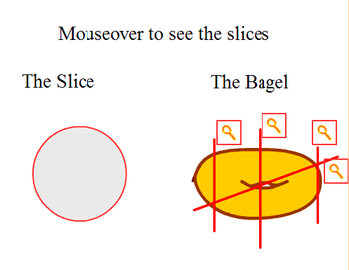

Match the slices
Another complication to think about is that most of the time you won't know which direction a slide "should" be facing -- which way is up. In the applet below, try to match the 2-D slices to the 3-D object. Type the number of each cut next to the slice it produces, and remember that the slices may be upside down, sideways, or slanted.
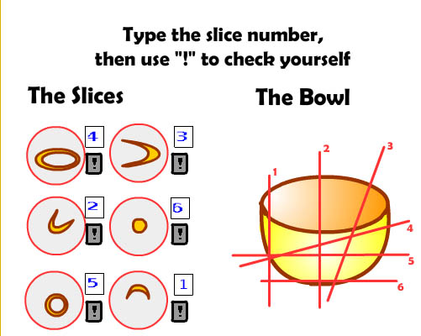

The versatile tube
Many biological structures involve tubes, so that's one shape you want to be able to identify in its various guises. Can you determine what the slice should look like?
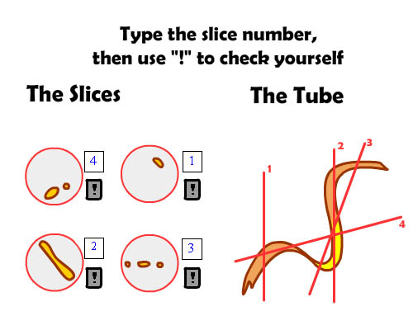
(Look online for a “spot the blood vessel” photo).

Slicing up the alphabet
The slices below are in order and "right-side up". Can you figure out which letter they came from? (Actually, there are 3 letters that work and one that almost works).
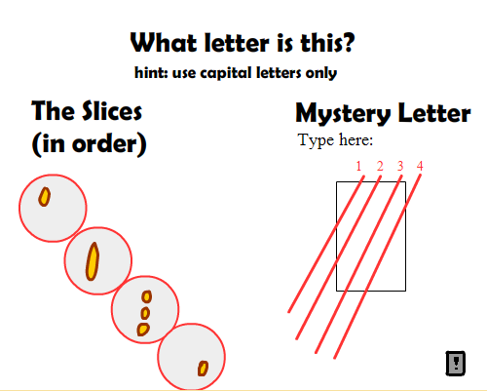
Answer: “E”

Organelles
Cell organelles are a lot more complicated than the shapes we've been talking about. One problem with using a microscope is that we have an idea in our heads about what an organelle should look like. This idea is 3-dimensional, and probably resembles the pretty pictures in the biology textbook.
If I tell you that an organelle is peanut shaped, with multiple shelf-like structures inside, you will (probably) recognize that I'm describing a mitochondrion. But the 2-dimensional structures you see on a microscope slide will most likely look nothing like that! Sure, once in a while you might get lucky and cut the organelle in just the right direction to see a cross-section of that peanut-shelf-structure, but not usually.
In the applet below, can you determine which organelle you are looking at just from the slices? As you click on each slice, you will set where it came from. After clicking on all 4, you will see the organelle itself.
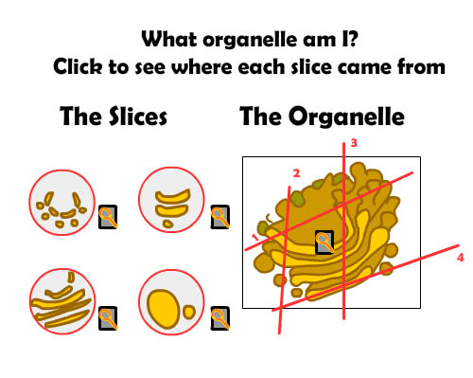
Visualizing a 3-dimensional structure in 2 dimensions is actually an enormously complicated process, and you could get into alot of really abstruse math while pursuing it, but luckily, we're going to stop here.

