
Population Dynamics:

Mystery of the Missing Housefly

URL: http://mathbench.umd.edu/modules/popn-dynamics_housefly/page01.htm

Note: All printer-friendly versions of the modules use an amazing new interactive technique called “cover up the answers”. You know what to do…

Introduction

This module attempts to answer the age-old question, if houseflies can lay a hundred eggs every two weeks, why don't they blanket the earth by now?
More generally, we get into all sorts of theories about how populations grow and why they don't grow as fast as they could.
There will be a few equations, but only a few, and a bunch of applets to demonstrate these equations.

The mystery begins
A typical housefly lives 6 weeks, and can produce 120 female offspring every 2 weeks. (There are also male offspring, but since they don't reproduce directly, it’s easier just to count the females).

By the ripe old age of 28 days, how many descendants should Ms. Domestica have?
- Ms. Domestica has 120 daughters, and each of them have 120 daughters!
- Multiply the number of daughters by the number of granddaughters each.

Answer: 14,400 grandbabies

Exponential growth
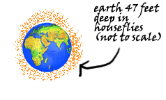
And two weeks later, there would be
14,400*120=1,720,000 great-grandkids,
attending Ms. Domestica's funeral (in addition to 14,400 grandchildren and 120 newborns).
Such is the power of exponential growth -- within 3 generations, almost 2 million flies are produced. By the end of the summer, according to various calculations, the earth could be covered anywhere from 23 to 47 feet deep in flies -- all descendents of the One Fly.

Population Dynamics
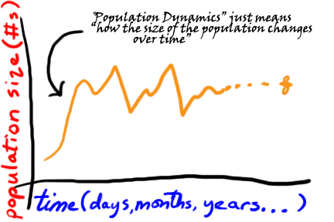
How the size of a population changes over time is called population dynamics. Exponential growth is one explanation for population dynamics, but there are others we'll talk about as well. Your job is to be a detective, and determine the most likely process or processes controlling the housefly population. Your tools will be a set of applets in this module that will allow you to investigate the patterns produced by different growth processes. Good luck!

Exponential growth equation
First, let's look more closely at exponential growth itself. According to exponential growth, a population is being multiplied by the same amount at each timestep. (By the way, I'm going to simplify slightly and say that flies reproduce at 120 per month rather than 120 per 2 weeks. This just makes it easier to talk about.)
 | 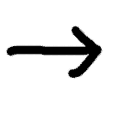 | 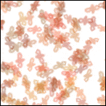
houseflies last month | → times 120 → | houseflies this month
Of course we all know that detectives need to write down clues – and for writing down clues we need a short-hand that is not only fast, but also secret and un-understandable for the uninitiated. Mathematical terminology is perfect for that (especially the un-understandable part, you're probably thinking). So here's another version of what we have above:
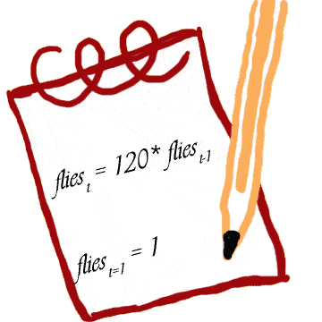
The subscript (t) refers to time. So you can read left side as “flies at time t”, and the right side as “flies at time t minus 1”. For example, if we're talking about month 4, then t stands for 4, and the equation above reads “flies in month 4 is equal to double the flies in month 3”. Well, that doesn't help much unless we also know the amount of flies in month 3. And in order to know flies in month 3, we need to know flies in month 2, for which we need to know flies in month 1. Aha! Finally a question we can answer. The number of flies at the beginning is called the “initial condition”. Once we know the initial condition, we can “iterate” (repeat over and over and over…) until we get up to the month we're really interested in.

You write the equation
OK, lets give it a try. I'm going to pick some small numbers, so as not to overwhelm your calculator. Let's say you start with 3 flies, and each fly lays 2 eggs at a time, which take 1 month to mature. After 1 month, all of the new flies lay eggs and die on the spot.
Your assignments are:
- write an equation for this process,
- write the initial condition
- iterate the equation for 12 months (use a calculator!), and
- graph the population dynamics
In case you need some hints:
- To write an equation, think about how flies_{t} (number of flies at time t)
relates to flies _{t-1} (number of flies the month before).
- The initial condition is simply how many flies there are at the Beginning of Time (flies₀)
- To iterate your equation, start at time 0 and work forward for 10 months,
making a table with months and flies as headings
- To graph the dynamics, just graph the table of numbers you created in the third step.

Applet: Exponential growth
You should end up with something that looks like this:  flies_{t} = flies_{t-1}*2  flies_{t=1} = 3  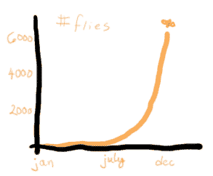
  Month | # flies
  Jan | 3
  Feb | 6
  Mar | 12
  April | 24
  May | 48
  June | 96
  July | 192
  August | 384
  Sept | 768
  Oct | 1532
  Nov | 3064
  Dec | 6128

The applet below allows you to investigate the exponential growth process further. The line that is already on the applet is the solution to the starting-with-3-flies, 2-eggs-per-fly-per-month problem above. You can change the growth rate (by moving the slider).
What happens to dynamics as the growth rate increases?
What if the growth rate is BELOW 0? In other words, if the population is experiencing negative growth?
The online version of this module contains an interactive applet which demonstrates relationship between exponential growth and growth rate. To find this applet go to: http://mathbench.umd.edu/modules/popn-dynamics_housefly/page07.htm | 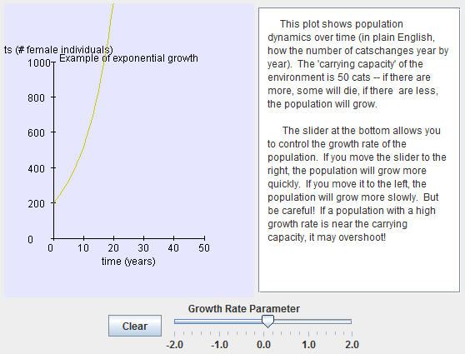

Summary of exponential growth
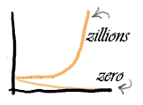
So, one way to summarize this is to say that the exponential growth process creates zillions of offspring for ANY growth rate that's bigger than 1. The zillions are created faster for high growth rates than for low growth rates. And if the growth rate is less than 1, then the population dwindles (again, slowly or rapidly) to zero. So the ultimate outcome is … either zillions or zero. No in between.
Not too interesting. Or too likely. So why study this model?
- It is a simple process that allows you to get your feet wet before jumping into more complicated stuff
- Many organisms behave AS IF their populations are growing exponentially, especially when they have small populations and lots of resources.

Assumptions about exponential growth
Our exponential model made a number of assumptions , two of which are:
1. all offspring survive
2. all flies have the same number of offspring
When you evaluate a model, one thing to think about is the assumptions of the model. Are they reasonable? Would a different assumption give you a different outcome?
Let's start with the assumption “all offspring survive”. That's obviously pretty unrealistic. Most fly offspring die as eggs or larvae or sometime before they could reproduce. This would be a violation of the assumption that all flies survive. (In case you're wondering, maggots need sufficient warmth, moisture, and food, and full-grown flies fall prey to birds, reptiles, and window sills).
So let's set up a new model, where 99% of the flies die before they have a chance to reproduce. Here's the old model equation:
flies _{t} = 120* flies _{t-1}
See if you can come up with an equation that describes each fly laying 120 eggs, but 99% dying.

Applet: once more with mortality
Here's one possible way to write the equation (there are other ways you could write it as well):
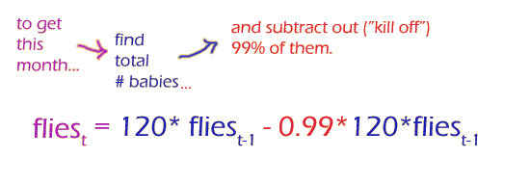
On the applet below, you can control both the growth rate and the mortality rate. How does this kind of population dynamics compare to simple exponential growth?
The online version of this module contains an interactive applet which demonstrate impact of growth and death rates on exponential growth . To find this applet go to: http://mathbench.umd.edu/modules/popn-dynamics_housefly/page10.htm | 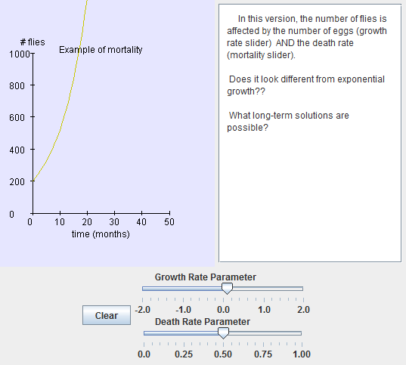
Do the results look at all familiar? In fact the shape of the graph is exactly the same as the regular exponential growth model. What gives?
Under exponential-growth-with-mortality, the population grows more slowly, but ultimately the result is the same: either the population "takes off" or it dwindles to zero. We'll discuss why on the next page.

...and an equation
Let's look at the equations in a little more detail:
flies _{t} = 120* flies _{t-1} - .99 * 120 * flies _{t-1}, which simplifies (using algebra only) to
flies _{t} = (120 - .99 * 120)* flies _{t-1} , and doing some math I get
flies _{t} = 1.2* flies _{t-1}
So, I can simplify the growth-and-death equation into something that looks a lot like an exponential growth equation. In both cases, the number of flies in a certain month equals the number of flies the month before multiplied by some constant number.
So we can say that these two models have the same functional form , and therefore the same shape on a graph. The form is
flies _{t} = r * flies _{t-1}
where r is the "rate of growth", taking mortality into account.

Examining assumptions
A while back we listed two critical assumptions of the exponential growth model. They were
- all offspring survive
- all flies have the same number of offspring every month
Then we investigated a violation of the first assumption, but that led to a dead end. Now we'll look into the second assumption, that all flies have the same number of offspring every month. There are lots of ways this could be violated!!
See if you can think of some before going to the next page.

Assumptions get violated
Here are some ways the second assumption could be violated:
- Individual flies might have different number of offspring depending on how fit they were (how much they had gotten to eat, whether they lifted weights or did aerobics, etc).
- All flies might have the same number of babies in any given month, but this number might be in different months – maybe in the summer flies reproduce faster, but in the winter, not so fast.
- The number of eggs per fly might also vary depending on how many flies there were – too many flies fighting for the same rotten banana might depress everyone's reproduction -- whereas if there are only a few flies on that same banana, everyone prospers and has babies galore.

Carrying capacity
Let's start with the last possibility: there are only a limited number of resources (rotten bananas and such) in the environment, which induces a carrying capacity .
Here's how a carrying capacity works. Let's say that 1 banana can support 100 flies, and in my house I have exactly one banana. If there are :
2 flies (very small population) : everybody gets lots to eat, and achieves their full reproductive potential. But since we only started with a couple of flies, the population doesn't grow too much.
50 flies (well below carrying capacity) : each fly gets plenty to eat. There are a good number of flies, and they reproduce like crazy. The population starts to take off.
90 flies (almost at carrying capacity) : everybody gets just a little more than they need to eat. The population grows, but only a little.
100 flies (carrying capacity) : each fly gets exactly enough to eat to be able to reproduce itself, so that next month there will be exactly the same number of flies.
110 flies (just above carrying capacity) : each fly get a little less than it needs. On average the reproductive rate goes below replacement, and the population declines.
200 flies (way above carrying capacity) : each fly is grossly underfed, spindly, and malnourished, and can barely get up the energy to … never mind. The population crashes. Only a few survivors are left to pick up the pieces.

...mathematically expressed
Since this is a math module, you know there will be an equation in here somewhere… Let's start by calling the carrying capacity “K” (ecologists are not known for winning spelling bees). We can think of the carrying capacity (K) as the number of 'slots' available for the population. The reasoning on the last screen was, if there are a lot of 'slots' left, then the growth rate will be high.
But how many slots is 'a lot'? If K=100, then 50 slots might be a lot -- but if K=1 million, 50 slots is not much in comparison. What we really need to know is how the number available compares to the carrying capacity.
Let's try some examples:
1. If K=100 and there are 95 flies (N=95), then there are 5 slots left, right? So the number of slots left is (K-N). We could turn this into the percentage of slots left if we divide by the maximum number of slots, like this: (K-N)/K, in other words, in our example, there are 5 out of 100 = 5/100 = 5% of slots left.
2. The capacity of an egg carton to carry eggs is 12 -- there are 12 spaces for eggs. In this egg carton, there are only (presently) 9 eggs. Therefore there are 12-9=3 spaces available. The proportion of spaces available is 3 out of 12, or 3/12, or 25%.
Make sure you understand how this works, as it is the key to understanding the equation on the next page.

If the carrying capacity in a room is 250 flies, and there are currently 100 flies buzzing around, what percentage of the ‘slots’ is available?
- What is the value of K, the carrying capacity? What is the value of N, the number of flies? Write these down.
- How many "free slots" are there?
- There are 250-150 = 150 free slots.
- What's the percentage of free slots?
- 150 / 250 = 3 / 5 = 60%

Answer: 60%

Logistic growth
So the major claim of the logistic growth model is this:
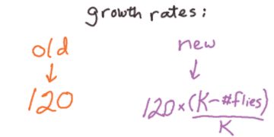
“the actual growth rate of the population is proportional to the percentage of slots available.”
In the exponential model, the growth rate was constant (i.e., every fly has 120 babies every month. No exceptions.). This led to some pretty ridiculous results. With the logistic model, the growth rate varies according to what proportion of ‘slots' are available. This will allow the output of the model to be much more realistic!!
So here's the entire equation:
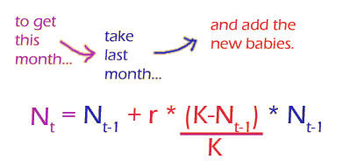

Applet: .... among elephants
Let's give this equation a test drive. In the applet below, YOU play the role of logistic growth. Look at the size of the population, and how many 'slots' are available. Then decide whether the population will grow, stay constant, or crash. Every time you click on the correct arrow, the computer will calculate the exact growth rate and display it for you.
We'll do this three times. In the first model, the highest possible growth rate is pretty low (common among large animals like… elephants).
The online version of this module contains an interactive applet which demonstrates population dynamics in elephants. To find this applet go to: http://mathbench.umd.edu/modules/popn-dynamics_housefly/page17.htm | 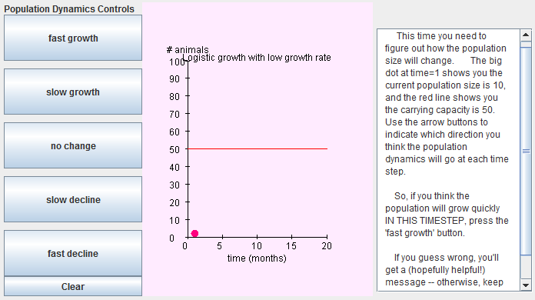
How would you describe this kind of population growth? Try jotting down a sentence before read: The population of elephants grew in a smooth, dignified way, slowing down when they came close to carrying capacity. This is the 'classic' pattern of logistic growth.

Applet: .... among mice
But don't think you've seen it all yet. Next you will look at a population where the maximum growth rate is a bit higher, such as voles.
The online version of this module contains an interactive applet which demonstrates population dynamics in mice. To find this applet go to: http://mathbench.umd.edu/modules/popn-dynamics_housefly/page18.htm | 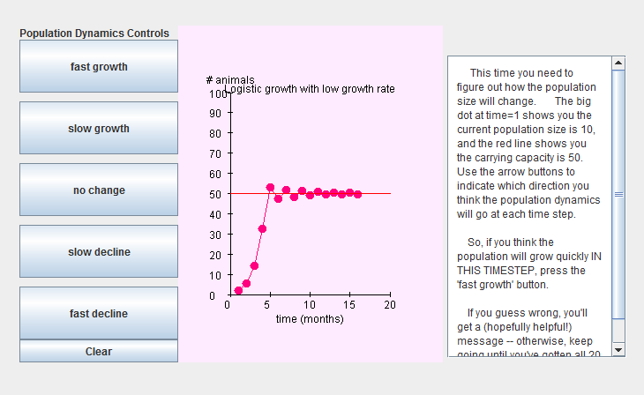
How would you describe this kind of population growth? Again, try jotting down a sentence before you continue. → Clearly, something different is going on with the voles. Their population growth does not slow down fast enough when they approach carrying capacity, so they overshoot. Then their population falls below carrying capacity. That sets them up to overshoot again. And so on, over and over. Something like over-correcting when driving a car, and ending up fishtailing between left and right curves.

Applet: .... among gypsy moths
OK, here's a final scenario. Some organisms, such as gypsy moths and (perhaps) houseflies can reproduce very rapidly. If voles overshoot, then gypsy moths and houseflies overshoot drastically. Give it a try:
The online version of this module contains an interactive applet which demonstrates population dynamics in gypsy moths . To find this applet go to: http://mathbench.umd.edu/modules/popn-dynamics_housefly/page19.htm | 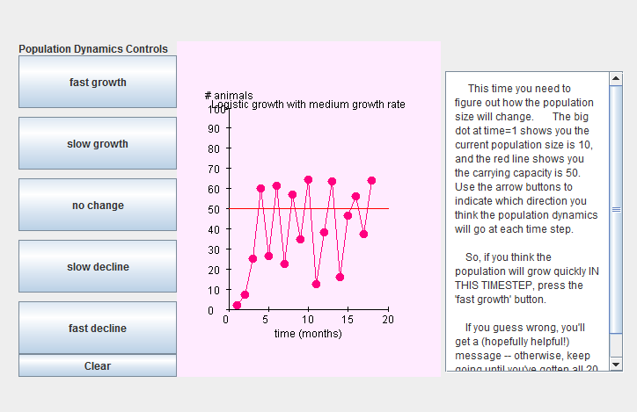

Detour: Chaotic dynamics
This is actually an example of something called “chaotic dynamics”. The population size is not actually unpredictable (after all, we're using an equation to calculate population size, so by definition we are predicting it) but it appears unpredictable. Even stranger, if two populations start out with only slightly different sizes, their population dynamics will get more and more different over time. Eventually knowing the size of the first population will tell you nothing about the size of the second population! This is called “sensitive dependence on initial conditions”.
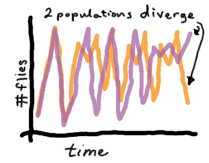
Hallmark of chaotic dynamics SDIC =
“Sensitive Dependence on Initial Conditions”
Whew, you've made it this far, which is through a lot of math. Here's the detective notebook:
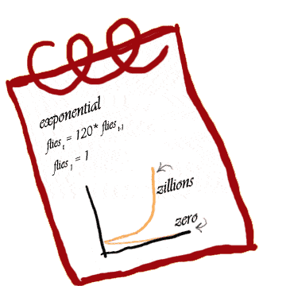 | 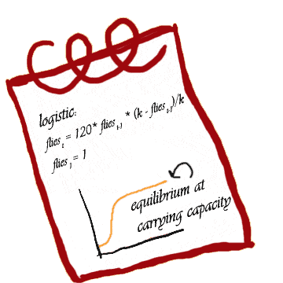

Applet: Seasonal changes
Just to round out your detecting skills, we'll talk about 2 other ways that the assumptions of the exponential growth model might be violated. But we won't go into the math so much for either of these.
An assumption violated, or:
Who says carrying capacity should stay constant?
When I first talked about carrying capacity, I made it sound like a fixed, immutable quantity, like an egg carton with a dozen eggs, for example. But that's not necessarily true. Lots of factors might affect how many flies can survive in a given environment, including how much food is available and how warm it is. Seasonal effects are especially common. Flies prefer temperatures in the 90s, but they can still fly at 53 degrees. At 48 degrees they're reduced to a crawl, and at 44 degrees they're virtually comatose. On the other hand, if the temperature climbs past 102 degrees, heat paralysis sets in, and at 116 degrees, they die whether or not you swat them. So if you graphed seasonal carrying capacity over time, it would have a hump during the summer:
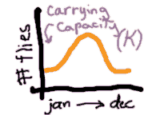
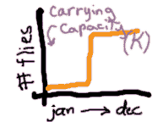
Alternatively, maybe I suddenly decide I love bananas and I start buying bags every week. Then carrying capacity might increase like a "step-function":
In this applet, you can see what happens when the carrying capacity changes over time in a variety of ways. Click the first button to change carrying capacity over the year. Then click the second button to watch dynamics change.
The online version of this module contains an interactive applet which demonstrates concept of carrying capacity. To find this applet go to: http://mathbench.umd.edu/modules/popn-dynamics_housefly/page21.htm | 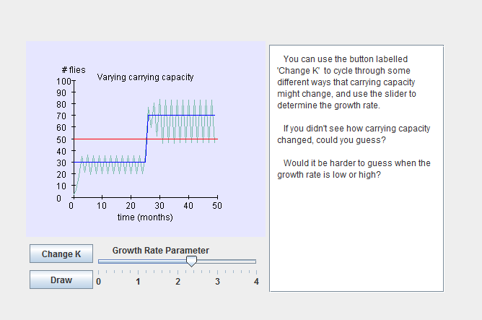

Applet: Disturbance = Death
Assumptions are made to be violated, part 2:
Hurricanes, earthquakes, and other acts of God.
Your insurance company knows that acts of god can wreak havoc with the best-laid plans. Likewise, disasters (known demurely as “disturbances” in ecology-speak) will not be good for a population.
Let's say I use a can of raid on the pesky houseflies and kill 95% of them. I know from experience that their population will recover... In the applet below, you can decide when the disturbance should occur, and watch the dynamics unfold:
The online version of this module contains an interactive applet which shows effects of disturbances on logistic growth. To find this applet go to: http://mathbench.umd.edu/modules/popn-dynamics_housefly/page22.htm | 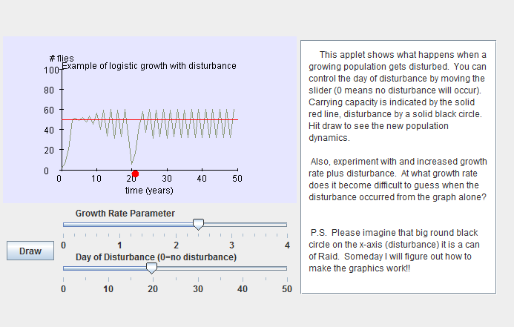

You be the detective
And here is a final applet: your job is to discover the actual form of population dynamics underlying the dynamics of Ms. Domestica's descendants. In other words, solve the Mystery of the Missing Housefly.
Directions:
Use the checkboxes to decide which of the 3 variants you want to use (you can use some, all, or none) and the sliders to control maximum growth rate, carrying capacity, yearly course of carrying capacity, and frequency of disturbance, as appropriate. When you think you've gotten the model to match the actual dynamics pretty well, press "reveal" to see what model the program was using.
The online version of this module contains an interactive applet which allows you to practice with exponential growth by varying different parameters. To find this applet go to: http://mathbench.umd.edu/modules/popn-dynamics_housefly/page23.htm | 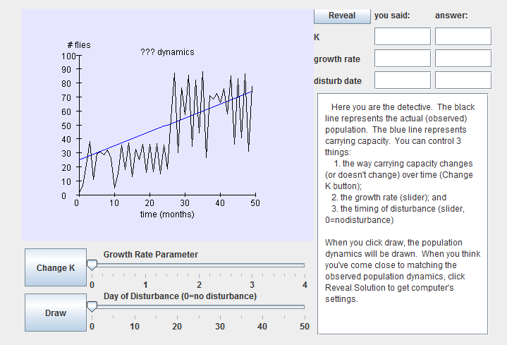

Just the facts ma'am
We didn't talk about equations for disturbance or changing carrying capacity, but actually they're pretty easy. We just need to modify the logistic growth equations a bit.
- To deal with changing carrying capacity, we'll say K _{t} instead of plain old K.
- To deal with disturbance, we'll add an extra equation to say that at the time of the disturbance, the population size drops to 5% of what it was just before.
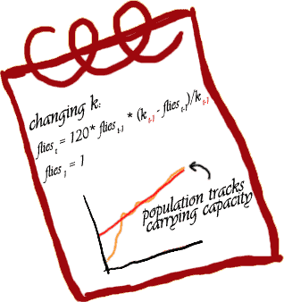 | 