
Measurement:

The Sizes of Things

URL: http://mathbench.umd.edu/modules/measurement_sizes/page01.htm

Note: All printer-friendly versions of the modules use an amazing new interactive technique called “cover up the answers”. You know what to do…

Tall (and small) tales
It was quite a sight to see, that cook of Paul Bunyan's making flapjacks. ...The table we had set up for the camp was about ten miles long. We rigged elevators to the table to bring the vittles to each end, and some of the younger lads in the camp rode bicycles down the path at the center, carrying cakes and such wherever they were called for. (Legends of Paul Bunyan, as retold by S. E. Schlosser)

I’m guessing it’s pretty clear to everyone that all of this is a tall tale. Why? You know that kitchen stoves aren’t 160 feet tall, and hair combs aren’t 100 feet long.

From your everyday life, not to mention the efforts of your elementary school teachers, you have an intuitive sense of what a foot, an inch, and a mile look like.

Now that you’re studying biology, you need to develop the same intuitive sense of what a millimeter, a micrometer, and a nanometer look like.

The hard part is that, while we can see an inch, things that are on the order of millimeters are kinda small, things on the order of micrometers can rarely be seen directly, and nanometers – you might as well forget seeing them without a really good microscope.

Nevertheless, we’re going to try to divide up the biological world into these scales and do what we can. Before we start, it will be helpful to have a ruler (or anything else that can easily measure millimeters) and a calculator on hand.

Metric conversions: step to the right, step to the left
First, the basics. One meter (which is oddly enough just about the same size as a meter stick) can be divided into 1000 parts called millimeters.

So, if I want to convert a measurement in millimeters to one in meters, I can do it by moving the decimal point 3 places to the left:

277 mm -> 0.277 m

Likewise, if I want to convert a measurement in meters to one in millimeters, I can do it by moving the decimal point 3 places to the right:

0.341 m -> 341 mm

If you don't have any decimal places to move to the right, then you need to add zeros:

345 m ->345000 m

34.5 m ->34500 m

A lot of people remember the part about moving the decimal point over by 3, but don’t remember whether it goes to the left or the right. There’s an easy solution for this: make sure your answer makes sense! Millimeters are pretty small. It’s going to take MORE millimeters than meters to make the same measurement.

A few big units = Lots of small units

If you convert the length of your finger (70 millimeters) into 70,000 meters, stop and think a moment. 70,000 meters is pretty ridiculous. Don’t pull a Paul Bunyan. (And believe me, at least one student does something similar on an exam every semester. Don’t let it be you!)

Here’s the part they don’t do in grade school: if you divide a millimeter into 1000 pieces, you get a micrometer, abbreviated µm, or um (being easier to type on a standard keyboard).

And if you divide a um into 1000 pieces, you get a nanometer, or nm.

So altogether now:

- 1 meter is 1000 millimeters
- 1 millimeter is 1000 micrometers (or microns, or µm, or um)
- 1 micrometer is 1000 nanometers (or nm)
- And the hip bone is connected to the thigh bone.

3 Worlds: Milli, Micro, Nano
We can roughly divide most phenomena of biological interest into 3 scales: the milliworld (1 meter to 1 millimeter), the microworld (1 millimeter to 1 micron), and the nanoworld (1 micron to 1 nanometer).

To get a first, rough intuition about these scales, it helps to figure out what belongs where. You already know plenty of biological phenomena that belong in the milliworld -- things like cats, mice, eyeballs, fruitflies... Notice that that's quite a range. The smaller worlds are harder to visualize because you don't see them every day.

So what’s in the microworld? Starting with the biggest stuff and going down…

- protists and single-celled animals
- cells of plants or animals (eukaryotes)
- bacteria (prokaryotes)

And what’s in the nanoworld? Again, starting with the biggest stuff …

- parts of cells (like mitochondria, chloroplasts, and so on) are right on the border between the micro and nano worlds
- visible light wavelength
- viruses
- cell membranes
- largish molecules (like proteins, carbohydrates, hemoglobin, etc)
- DNA double helix
- small organic molecules (like simple sugars)

I am not trying to say that there is some kind of magical division between the microworld and the nanoworld, or that the rules of physics suddenly change, or anything like that. The reason that I’m talking about microworld and nanoworld is just to give you a point of reference, to help you figure out which units will be most convenient, and which biological structures have similar sizes.

Going back to P. Bunyan for a moment, you know there are things that are convenient to measure in feet (stoves) and other things that are convenient to measure in miles (rivers). You don’t mix them up, but you also know that ultimately they belong to the same continuum.

Focus on the microworld
Notice how micrometers have a lot of names? You can call them microns (this will sound like you know what you are talking about, in case you have a crush on a biologist), or you can call them micrometers (accent on the “o”), or "um", or use the greek letter, µm.

Microns got so many names because in a lot of ways, they have gotten the most attention from biologists. From the invention of the optical microscope in the 1600s all the way until the mid-1900s, biologists have been able to see into the micro-world, but not farther. So, naturally they came up with a lot of terms for micrometers.

The microworld has been very important in biology, and you’ll spend much of your first year in biology getting familiar with what happens there. And we actually can do a little bit of hands-on measurement of the microworld.

What we’ll do is measure a stack of thin things in order to figure out how many microns each individual thin thing is. Got it? Good.

For example, take your ruler and measure of 1 millimeter worth of pages in your textbook.

How does this relate to microns? Recall that 1 mm is 1000 um. So, for example, if there were 2 pages in a millimeter, you would divide 1000 mm by 2 to figure out that each page was 500 microns thick.

I got 14 pages to the millimeter in my textbook, which made my pages 71 um each (approximately). Just for fun I also tried it with:

- a stack of index cards (200 um each)
- the Washington DC Yellow Pages (67 um each)
- and 7th generation Unbleached toilet paper (100 um each)

So in general I think we can conclude that most paper is around 100 um thick. Squarely in the microworld.

Practice Measuring in the MicroWorld
The microworld, as we defined it, goes from 1 to 1000 microns. We know that paper is about 100 microns. What about stuff smaller than that?

Below is a scale drawing. Your job is to eyeball the sizes of the different things in this world using the drag-and-drop microscope viewing area.

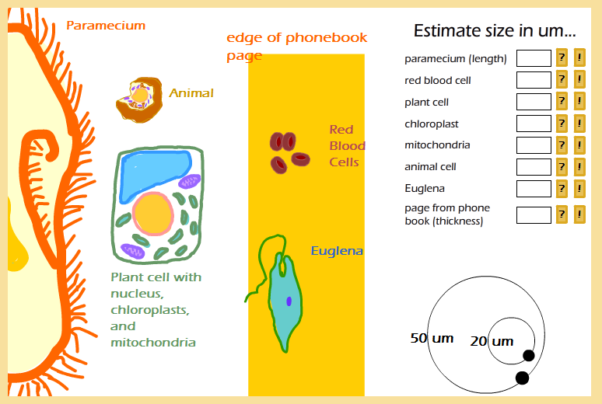

Answers: 50, 7, 50, 8, 10, 20, 40, 100

So once again, the microworld is basically the world of cell-sized things, from giants like multicelled animals (dustmites), to big singlecelled organisms (like protists, euglena and paramecium), down to plant and animal cells ( generally in the 5 to 30 um range). Some of the largest structures inside cells, like the nucleus, mitochondria, and chloroplasts, are just at the bottom of the microworld.

Next stop … the nanoworld
Cells and bacteria belong in the microworld; organelles like the nucleus, mitochrion, and chloroplast just barely belong to the microworld. You can think of the cell as a microworld city, and the organelles as microworld-sized factories within that city. The machinery of the cell organelles, however, belong to the nanoworld. That includes the DNA that contains instructions and the enzymes that do the actual work, the food molecules like glucose to be metabolized, the membranes that keep the cell interior safe, and even the viruses that infect the cell. All of these are nano-sized….

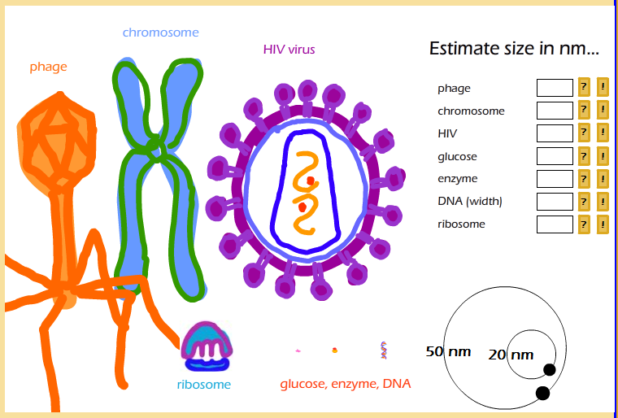

Answers: 200, 100, 80, 1, 2, 2, 10

So at the top of the nanoworld would be the smallest bacterium, measuring in at 1000nm. Visible light is somewhere in the middle – between 340 and 780 nanometers. Below that are most viruses, including my favorite, the T4 (which looks like a lunar lander, and helps protect us against E. coli gone bad) and one on everyone’s least favorite list, the HIV virus. At 100 nm, Chromosomes are about the size of small viruses, which makes sense considering that viruses are basically just DNA in a protective coat. Smaller than that are the enzymes, membranes, DNA strand, and at the very bottom, a glucose molecule, coming in very close to 1 nanometer.

End of the line… the picoworld
Of course there are things smaller than glucose. Water molecules, for example. Carbon dioxide. Hydrogen atoms. Chemical bonds. Most of these things are in fact in the picoworld – you guessed it, 1 picometer = 1/1000 nanometers. However, if you want to go there, you’ll have to find a different tour guide.

But, bottom line, don’t expect to find molecules with less than about 20 atoms in the nanoworld.

And really REALLY don’t expect to find the building blocks of atoms -- protons, neutrons, or electrons -- there.

However, I strongly recommend taking a look at the following site: Cells Alive (http://www.cellsalive.com/howbig.htm). It is a very nice animation which allows you to zoom in and out on some things in the micro and nanoworlds, with much better production values than my stuff here!

What to memorize
I hope you’ve enjoyed the tours of nanoworld and microworld. In case you’d like a short list to memorize, here’s a suggestion:
- 900 um fly's eye
- 100 um paper
- 7 um red blood cell (on the small side for a plant/animal cell)
- 1-10 um bacteria, mitochondria, and chloroplasts

And in the nano world:
- 100 nm viruses
- 10 nm cell membrane
- 2 nm DNA double helix
- 1 nm glucose molecule

