
Measurement:

Logs and pH

URL: http://mathbench.umd.edu/modules/measurement_logs/page01.htm

Note: All printer-friendly versions of the modules use an amazing new interactive technique called “cover up the answers”. You know what to do…

When size matters
As you may have noticed, scientists like to measure things. Not just anything they can get their hands on, but also lots of things that are too big to get their hands on, and lots of things that are too small. For example:
too big | too small
rainforests  planets  solar systems  galaxies  universes | grains of pollen  blood cells  E. coli  enzymes  carbon atoms  electrons
What ends up happening is that we need a lot of zero's to express these sizes. For example:
# stars in our galaxy = 100,000,000,000 (roughly)
distance from here to the edge of the universe:
94,608,000,000,000,000,000,000 km (roughly!)
The problem is just as bad when we talk about small things:
diameter of a red blood cell = 0.000007 m
mass of a carbon atom = 0.0000000000000000000000199 grams
Obviously these are numbers that are hard to deal with. A red blood cell with a diameter of 0.00007 m instead of 0.000007 m would be 10 times too big to fit through a capillary, yet it's hard to tell the numbers apart by looking at them – and hard to remember how many zeros there are supposed to be in the first place!

There must be a better way!
Indeed there must. Scientists often use an alternative numbering system called a “log” scale. When you put a number on a log scale, you are basically saying “how many zero's are in that number?”
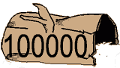  log size 5 needed -- to hold 5 zeros.  Log(10,000) = 5 | 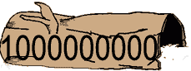  log size 9 needed -- to hold 9 zeros.  Log(1,000,000,000) = 9
For example, the stars in our galaxy: a hundred billion is a 1 with 11 zeros after it, so the log scale version of this number is simply 11.
log(100,000,000,000) = 11
On the other hand, the E. coli diameter has a decimal point and 5 zeros, so that's a -6 (tricky point – you have to include the decimal point when counting zeros for numbers less than 1).
log(0.000002) = (approximately) -6
"Counting the zeros" is the same as saying "what power would I need to raise 10 to in order to get this measurement?" That's important, but hard to remember. The short version of "what power would I need..." is ...


Your turn
The online version of this module has an interactive applet which allows you to practice estimating the logs of biological measurements. To find this applet go to: http://mathbench.umd.edu/modules/measurement_logs/page03.htm | 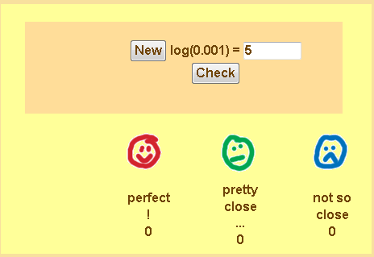
By the way, if you know the log value and you want to find the original value of the number, how do you do it?
Use the anti-log, of course!! However, if your calculator doesn't have an anti-log key, you can raise 10 to the log, or use the 10^{x} key. For example, the log of the pollen diameter was -4.5, therefore the diameter in meters is
10^{4.5} = 0.0000316 m
If you are using Google as a calculator, type "10^4.5 = " and hit enter.

Why is an E. coli "APPROXIMATELY" a -6?
I was trying to keep things simple when I said approximately -6. To be more exact,
log(0.000001) = -6 (remember, count the decimal place and then the zero's).
But E. coli are bigger than that. Not big enough to get to a log scale number of minus 5, but somewhere between minus 6 and minus 5. If you have a calculator, you can easily find that
log(0.000002) = -5.7
Likewise, red blood cells have a diameter of 0.000007 m, so they are also between minus 6 and minus 5 on a log scale:
log(0.000007) = -5.2
So log(E coli diameter) is -5.7, while log(red blood cell diameter) is about -5.2 – in other words, red blood cells are not as small as E. coli.
Now that we know that normal red blood cells are approximately -5.2 on a log scale, we can also guess that a blood cell that is a -4 is going to be very problematic for the poor creature whose capillaries get exploded by it. And a red blood cell that's a -6 will be too tiny to do any good. | 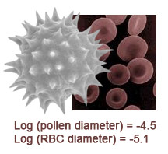

A red blood cell diameter is -5.2 on the log scale, while a typical pollen grain is a -4.5. Which is smaller?
- The more negative the log, the smaller the measurement.
- The log of red blood cell diameter is more negative than the log of pollen grain diameter, so it must be smaller.

Answer: The red blood cell is smaller.

Your turn again
The online version of this module has an interactive applet which allows you to practice estimating the logs of biological measurements. To find this applet go to: http://mathbench.umd.edu/modules/measurement_logs/page05.htm | 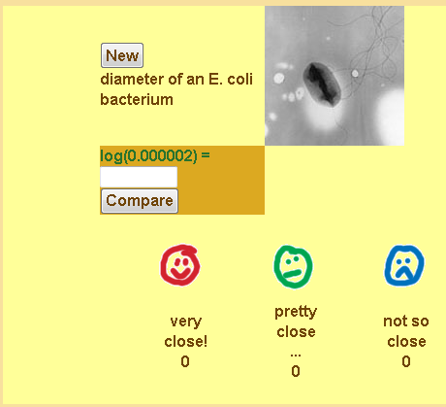

How big is a grain of pollen (given that log(diameter) = -4.5)
- Remember that the log is defined as the exponent you need to raise 10 to in order to get your original number.
- Raise 10 to the log to get the original measurement back.
- Use the 10^{x} key on your calculator, or type "10^-4.5 = " on google.

Answer: 10^{-4.5} = 0.0000316 m.

What else do scientists use logs for?
Any time that a measurement can vary over many orders of magnitude, that's a candidate for using a log scale.
One example is the pH scale, which shows the concentration of hydrogen ions [H⁺] in a water-based solution. The concentration can be as high as 1 mole of H⁺ for every 10 L of water (extremely acidic), or as low as 1 mole of H⁺ for every 100,000,000,000,000 L of water (extremely basic). For a refresher on describing chemical quantities in moles, see the MathBench module on Calculating Molar Weight.
Instead of counting out the zeros every time, we use a log scale. pH is defined as the negative log of the H⁺ concentration.
extremely acidic : [H+] = 0.1 moles/L : pH = -log(0.1) = 1
extremely basic : [H+] = 0.00000000000001 moles/L : pH = -log(0.00000000000001) = 14
Imagine that the space below shows a very tiny quantity of water (9 x 10⁻¹⁵ liters, to be exact). Three images below represent pH 1, 3 and 5.
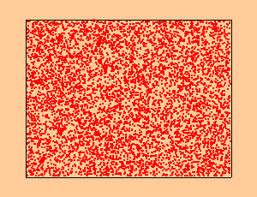 | 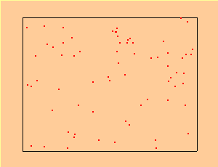 | 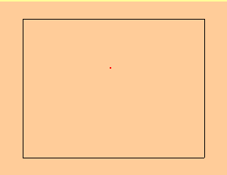
pH 1  [H+] = 0.1 moles/L,  -log(.01) = 1 | pH 3  [H+] = 0.001 moles/L  -log(.001) = 3 | pH 5  [H+] = 0.00001 moles/L  -log(.00001) = 5
Unfortunately, we can't get any less acidic than that, because we'd have to make the page huge!! To get a pH of 14, we'd need the page to be more than 10,000 times taller and 10,000 times wider, and this humongous page would contain only a single dot.
As a general rule, when you add 1 to a log number, it’s the same as multiplying the unlogged measurement by 10:
1 on a log scale corresponds to 10 on an arithmetic (linear) scale
2 on a log scale corresponds to 100 on an arithmetic (linear) scale
3 on a log scale corresponds to 1000 on an arithmetic (linear) scale
and so on...
It works a little differently with pH, because pH is the negative log of concentration. So, every time we SUBTRACT a single pH unit (like going from 2 to 1), we multiply H+ by 10.

Another example: The Richter Scale
Here's another example you probably won't see in your biology class (unless you get your TA really mad, maybe), but you've probably heard of it. Earthquakes are measured on a scale of 0 to 9, corresponding to how much energy they release. This is a log scale, so each point on the Richter scale represents a ten-fold increase in energy.

Two earthquakes hit the Twin Cities -- the St. Paul earthquake measures 1.0 on the Richter scale, the Minneapolis earthquake measures 3.0. How much MORE energy was released in Minneapolis?
- How much more energy is released in a 2.0 earthquake compared to a 1.0 earthquake?
- How much more energy is released in a 3.0 earthquake compared to a 2.0 earthquake?
- Going from a 1.0 to a 2.0 earthquake releases 10 times as much energy, and then going to a 3.0 earthquake releases 10 times as much again. So altogether 10*10 times as much energy was released. The same as saying 10² times as much energy.

Answer: 100 times as much.

The tsunami at Christmas 2004 measured 9.3 on the Richter scale, while the San Francisco earthquake of 1906 measured 8.0. How much MORE energy was released in the Christmas Tsunami?
- The difference between the tsunami and the earthquake was 1.3 on the Richter scale.
- The anti-log of 1.3 is 10^{1.3}
Answer: 101.3 = 19.5 times more energy

pH again
You can use the same kind of logic on pH. Here are two problems

The pH of lemon juice is 4.2. The pH of milk is 7.8. What is the difference in hydrogen ion concentration (approximately)?
- The difference in pH is 7.8 - 4.2 = 3.6
- So the difference in concentration will be somewhere between "3 zeros" and "4 zeros" (between 1000 and 10000).
- 10^{3.6} = 3981.
- Make sure you know which one is more concentrated!
- Lemon juice is more acidic, so it should have more H+. Therefore, lemon juice has 10 ^{3.6} = 3981 times as many hydrogen ions as milk.

Answer: 3981 times as much.

The pH of lemon juice is 4.2. How many moles of H+ are present in 5 L of lemon juice?
- Use "the log is the power" to figure out the amount of H+ in 1 L of lemon juice (and don't forget to use MINUS 4.2...)
- If you forgot the minus sign, you end up with 16,000 moles of H+ in 1 L of lemon juice, which is obviously wrong! ... Then you remember the minus sign.
- So how much of H+ in 5 L?
- 10^{-4.2} = 0.000063 moles, so 5 L of lemon juice contains 5 times as much -- 0.000315 moles of H+.

Answer: 5 * 10^{-4.2} = 0.000315 moles of H+

Important Things to Remember about Logs (or else...)
Logs make it easier to compare measurements that vary by many orders of magnitude.
Positive logs mean big numbers – bigger than one.
To find the approximate log, simply count the number of digits AFTER the first digit.
Negative logs mean small numbers – smaller than one.
To find the approximate log, count the decimal point plus number of zero's UNTIL the first non-zero digit.
Logs are the same as the exponent you would need to put on a "10" in order to get your original measurement: in other words, The Log is the Power.
Going UP BY ONE on a log scale is always the same as multiplying by 10. Going DOWN BY ONE on a log scale is always the same as dividing by 10.
You can recover the original measurement by raising 10 to the log ( or "10^___ =" on Google).
The pH scale is based on the NEGITIVE log concentration of H+ ions
The Richter scale is based on the log of energy released.

