
Measurement:

Straight Lines/ Standard Curves

URL: http://mathbench.umd.edu/modules/measurement_beerslaw/page01.htm

Note: All printer-friendly versions of the modules use an amazing new interactive technique called “cover up the answers”. You know what to do…

Rates of change
We will start by talking about DIRECT PROPORTIONALITY instead of about spectrophotometers.
Directly proportional means that as one thing increases, the other increases by the same proportion. Think about your favorite hourly wage job (for example, topping pizzas at minimum wage):
• If I work twice as many hours in a week, my paycheck is twice as much.
• If I get sick and work only 75% of the time, I get 75% of the money.
• If I don't work at all, I don't get any money.
Directly proportional is what little kids think of as “fair”. It wouldn't be “fair” to work double the hours but make only 10% more! And, while it would be nice to work 75% of the hours but still make 100% of the paycheck, I guess that wouldn't be “fair” either.
Relationships that are directly proportional can be shown on a graph as a straight line that goes through (0,0) – if I don't work at all, I don't get any money. And they look like a straight line – for each extra hour I work, I make the same amount of money. But other than that, the graphs can look quite different. Look at the graphs below to see the difference between several professions:

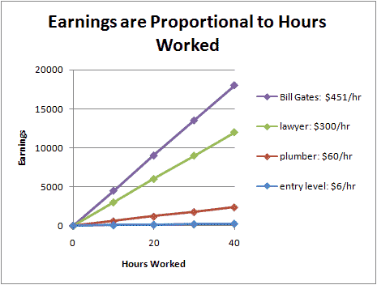
In all cases, our pay is directly proportional to our work hours – double the hours, double the pay. But some people are accumulating money a lot faster than other people. That is reflected in the steeper slope of some lines (like Bill's).

Slope = rate
Here's another graph:
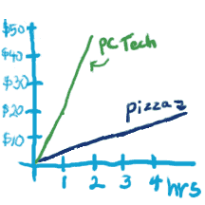
Looking at the graphs, can you figure out how much each person makes per hour? In other words, what the change in money per time is?
Pizza delivery: $ 6/ hour
PC Tech: $ 25/ hour
You may recognize "change in money per time" as being basically the same as delta y / delta x, which is the classic formula for slope. This is no accident.

If you can engrave this on your brain, you'll have a head start interpreting lots of graphs, whether they are straight lines or not. The slope at any part of a graph tells you how fast the process is happening right then.

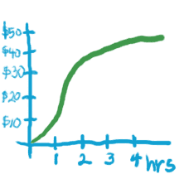
The graph represents my earnings over a period of 4 hours. At what point in time am I earning money at the fastest rate?
- Slope = Rate
- Where is the slope the steepest?

Answer: At about the 1.5 hour mark.

Match the rate (fast, medium, slow) with the right slope:

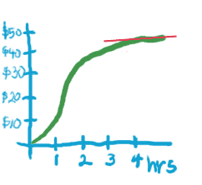 | 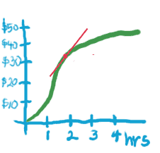 | 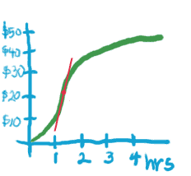
(a) | (b) | (c)

Answer: (a) slow, (b) medium, (c) fast

A Line has only 1 Slope
A line is very simple in that it has the same slope everywhere. So, to find out how much a PC tech makes per hour, you just need to measure how much we made in any single hour – such as the first one:
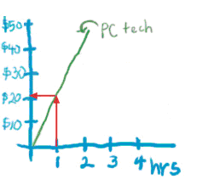
If you want to get fancy, you can pick a different hour, but to me it seems like more work for the same answer. For example, you could say, between hours 1 and 2, the PC Tech earned $42 - $21 = $21 extra dollars:
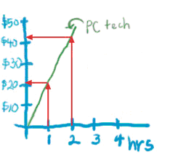
I mention this only because when people want to demonstrate finding a slope, they often draw a figure that looks like this;
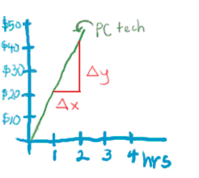
But you now know that, assuming the line goes through (0,0), its much easier to find the slope by just finding the value of y at the x=1. If it’s not possible to distinguish the value of y at x=1, then you may need to use a larger number:

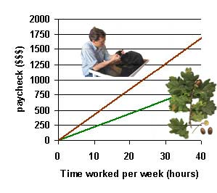
What is the pay rate for the forest conservation worker? How about the veterinarian?
(All wage data taken from Monster.com)
- It's not really possible to see (the value of the paycheck) at x = 1 hour. So pick a bigger x value, like x = 10 hrs.
- If the forester works 10 hours, she makes 220 dollars...
- 220 dollars / 10 hours = ? dollars / 1 hour
- Now do the same for the vet…

Answer: Forester = $22/hr, Veterinarian = $42/hr
The equation for a straight line is
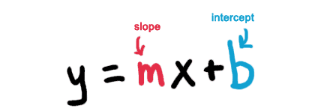
"Intercept" is just a fancy word for "where the line crosses the y axis". We know that the lines we're talking about go through (0,0) -- there, the intercept must be zero, so the equation is simply y = mx.

Direct Proportionality in a Spec
So, you're asking, what did all that have to do with spectrophotometers?
Here's the short answer: a spectrophotometer is a device that measures how much light a solution absorbs, which is DIRECTLY PROPORTIONAL to the concentration of the solution.
If you don't clean a fish tank for a long time, the water gets murky, right? That happens because lots of stuff (bacteria, algae, waste products) is floating around. And how can you tell lots of stuff is floating around? Because it's hard to see through. In a really bad case, you can't even find the fish. So, stuff floating around means light can't get through the water.
What if you could figure out a relationship between how much light gets through and how much stuff is floating around? Then you would have an easy way to figure out how badly off your fish are. Instead of taking a water sample, adding chemicals to preserve the cells, putting it under a microscope, and counting hundreds of tiny cells, you could just shine a light through it and measure how much light came out!
This is exactly what a spectrophotometer does. You take a solution, figure out what wavelength of light is most useful (more on that in a sec), then shine that light through and record how much got absorbed. Finally you use a graph like the one below to “translate” how much light got absorbed into how much stuff was in the water (officially, to “find the concentration of the solution”).
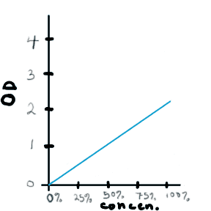
Wow, cool, notice the DIRECTLY PROPORTIONAL relationship here.
- No gunk, no light absorbed.
- A little gunk, a little light absorbed.
- Lots of gunk, lots of light absorbed. Bye bye fish.

What is the slope of the graph above?
Before you can even start to answer this, you need to think about units. Y is measured in OD units (whatever they are... we'll get to that). X is concentration, which ranges from 0 percent to 100 percent. So a useful unit for x would be "percent concentration". Thus the units of the slope are "OD / percent concentration"
- Approximately what is the value of y at x=50?
- At x = 50, y = 1, so the slope is 1/50
- 1/50 simplifies to...

Answer: 0.02 units OD/percent concentration
In other words, the OD increases by 0.02 units for every additional 1 percent concentration of gunk.

Beer's Law:
A Relationship between gunk and light
In order to design a machine that calculates the amount of gunk by measuring how much light gets through, we need to know what the relationship between gunk and light is. Luckily, the relationship is actually DIRECTLY PROPORTIONAL, and all we need to figure out is the slope. So let's write the equation, keeping in mind that ...
Instead of x, we say c (for concentration).
Instead of y, we say OD (for optical density, which is the technical way of saying “how much light the gunk absorbed”).
Instead of m, we say e (which stands for “extinction coefficient”, i.e., the amount of light that is extinguished by each extra bit of gunk). So we get:
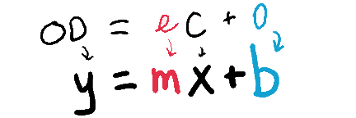
Just to make it a little trickier, the amount of light absorbed also depends on how big your fish tank is. A 2 foot tank will absorb twice as much light as a 1 foot tank. Another DIRECTLY PROPORTIONAL relationship. So, to be really correct, we have to write the equation like this:
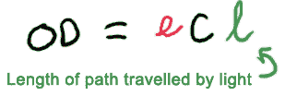
where "l" stands for the “length of the path” that light follows.
Luckily, those people that designed the spec were pretty smart: they keep the distance that light has to travel constant, and they make it equal to 1 cm, which means in practice we can just use the easier equation, OD = ec.
By the way, this particular equation has a name that's pretty easy to remember: Beer's Law. Yes, there was a person named Beer (Herr Professor Beer, actually).

Why do we have to do this?, or
Making a Graph for our Spec
We still need to know the rate at which light gets absorbed ("e"), so we can interpret what the spec is telling us. But how do we get that rate? Just like there are lots of possible rates for paycheck vs. time spent working (depending on what your job is), there are also lots of possible rates for absorbance vs. concentration (depending on what kind of solution you're testing).
The only way to find the correct rate is by measuring it. And before we can even start measuring, we need to know what wavelength of light to use. This depends on what you're testing. Pure water (at least in small amounts) doesn't absorb any light, so all wavelengths (colors) get through, and mixed together, they look like white ( = colorless) light. Gunky fish tanks appear greenish because whatever is in there absorbs the other colors of light. The more gunk that's in there, the more non-green light gets absorbed -- and correspondingly, what does get through looks greener.
The online version of this module contains an interactive applet that allows you to practice with virtual spectrophotometer. To find this applet, go to: http://www.mathbench.umd.edu/mod105_1b_beerslaw_TOC/page06.htm | 
Now, let's think about this a little differently - the light does not actually have more green at all, it has the same amount it always had. What is really happening is that you are seeing LESS of the red and blue colors so that the green becomes more prominent. In other words, the amounts of the colors you DON'T see are changing in proportion to the amount of gunk! So, if you want to measure the concentration of gunk in green water you need to set your spec to measure the absorption of one of the other (non-green) colors.
Likewise, red coolaid absorbs all the light except red. To test the concentration of coolaid, you would need to set your spec to measure something other than a red wavelength.
So in general, before you use a spec, you have to figure out what wavelength works the best. How do you do that? More or less by trial and error. But after you've figured out the best wavelength, you can proceed to the next step, actually measuring e...

How to determine e, the long version....
You need a graph that looks like one of these:
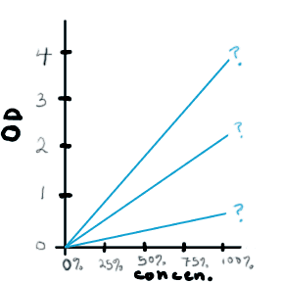
You can make this graph by measuring absorbance for solutions with a few different concentrations. Then you need to draw a line through the dots. Now, when I say "draw a line through the dots", please DON'T think this means simply connecting the dots as if you were doing a dot-to-dot puzzle. Instead, you want a single straight line that goes approximately though the center of your group of dots, so some dots are above and some are below the line, but all are as close as possible. (In statistical circles, this is known as "doing a linear regression," and there are mathematical ways of ensuring you have the closest fit, but this is NOT required in this module.)
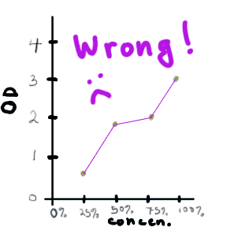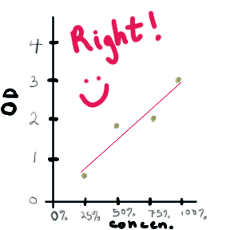
So let's say you want to find out what "e" is for Beer. (Incidentally, I am not the first one to come up with this brilliant idea. The magazine "Brewing Techniques" published a long, controversial, and apparently quite serious series of articles on this back in the mid 1990's. Maybe the idea is to use a spec to figure out when the beer is “done”. According to the articles, some people don't believe that beer actually follows Beer's Law – how's that for irony?)
Back to finding out "e" for beer. You would take a sample of beer, dilute it to 25%, run it through the spec, and mark your data point on the graph. Then you need to do the same with a 50% sample, a 75% sample, and a 100% sample. According to Brewing Techniques, for Black Tusk Ale, you then get a graph that looks like this:
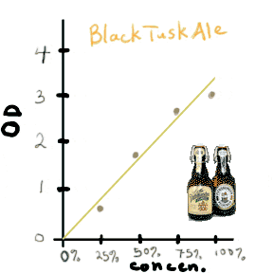
Now that we have a graph, we can find the extinction coefficient "e" -- which is the same as the slope of the line :
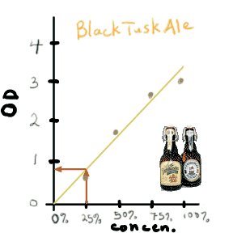
So, for every 25% change in concentration, OD increases by about 0.8 units. The slope of the line is 0.8 / 0.25, or 3.2, which is also the value of "e", the extinction coefficient. For Black Tusk Ale, Beer's Law is OD = 3.2*c.

Now you try it...
John and Suzy want to measure the strength of various mixtures of red koolaid. After finding the proper wavelength, they run 10, 20, 40, and 80% solutions through a spec, and get the following data:
concentration | 10% | 20% | 40% | 80%
absorbance | .31 OD | .59 OD | 1.2 OD | 2.3 OD

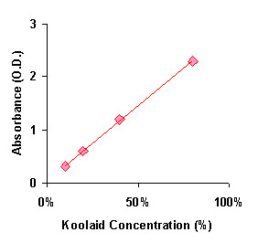
Then they go to the State Fair and get samples of red koolaid from 3 different vendors. These samples have absorbances of 0.7, 1.5, and 2.6 AU. How strong is each glass of koolaid?

First, what is “e”?
- Remember that “e” is the rate at which stuff in the water absorbs light.
- Slope = rate
- Find the slope of the graph.
- How much does the absorbance change as you go from 0 to 10% koolaid?
- Since Beer's Law says the relationship is DIRECTLY PROPORTIONAL, then the absorbance will change 1/10 th as much from 0 to 1% as from 0 to 10%.

Answer: e = 0.03 AU / percent koolaid.

So far, we know that e = 0.03 OD / percent koolaid. Fitting that into our equation, we get
OD = 0.03 c

Now that you have “e”, what are the concentrations of the three koolaid samples (their OD's were 0.7, 1.5, and 2.6 AU's)
- you can write an equation for concentration based on absorbance.
- To get the equation for concentration, do this:
OD = e c
c = OD / e
c = OD / 0.03
- Use Google as a calculator!

Answer: 0.7/0.03 = 23%, 1.5/0.03=50%, 2.6/0.03 = 87%

Looking back
What you are practicing here is called calibration, or creating a standard curve. You need to do this when you use a spec.
Often, when you use a measuring tool, it has already been calibrated – for example, someone a long time ago figured out how to use the pipetman to measure 10 microliters, 20 microliters, 30 microliters... and then that kind-hearted person created a volume indicator to make it easy for you to use the pipetman. That means that you (being a person using the pipetman) don't need to figure out every pipetman all over again.
It's very convenient to have our measuring tools come pre-calibrated – that's why we use an electronic scale and graduated cylinders and so on. But not everything can be pre-calibrated. Sometimes the calibration has to depend either on environmental conditions or on the thing that you're trying to measure. In that case, you need to do the calibration yourself.
Specs, of course, don't come pre-calibrated. When you use a spectrophotometer, you need to calibrate it yourself. Why? Because there are thousands of different kinds solutions you could measure. Each one has its own extinction coefficient. This process of calibration is also called “creating a standard curve”. That is “standard” as in something you can measure against, and “curve” as in a function drawn on a graph. The word curve is a little unfortunate, since straight lines are anything but curvy, but that's the word we use.
Once you have the standard curve, you can use it in one of two ways:
1. Figure out the function which represents that curve, and use that function to translate your measurements -- that's why you had to find “e”.
2. Simply read the translation from the curve itself – this is faster but less accurate, plus you have to carry a graph around.
The reason I spent so much time on this is that biology (and science in general) is full of instruments that need to be calibrated and standard curves that need to be figured out. Once you understand the logic of what you're doing, all of the procedures make intuitive sense.

Just the facts, please
- A graph representing a DIRECTLY PROPORTIONAL relationship is always a straight line passing through (0,0).
- You can measure the slope of this graph by finding the value of y at x=1.
- If that's not feasible, you can find the first feasible value of y, then divide by the value of x.
- The slope of the graph is the same as the rate of change of y.
- The relationship between light absorbed and gunk is directly proportional, and can be written as
OD = e c,
where OD=optical density, e=extinction coefficient (a rate), and c = concentration.
- In order to calibrate a spec, you need to know the best wavelength to use, which generally is some wavelength other than the color of the solution being tested.
- Once you know the wavelength, you need to create a series of different concentrations and measure the OD of each (with the spec).
- You use this data to calculate "e" (the slope of the line).
- Once you know e, you can solve the equation above for c, like this:
c = OD / e,
which allows you to measure the OD of any similar solution and calculate its concentration.

