
Cell Processes:

Osmosis

URL:
http://mathbench.umd.edu/modules/cell-processes_osmosis/page01.htm

Note: All printer-friendly versions of the modules use an amazing new interactive technique called “cover up the answers”. You know what to do…

Osmosis is a special kind of diffusion
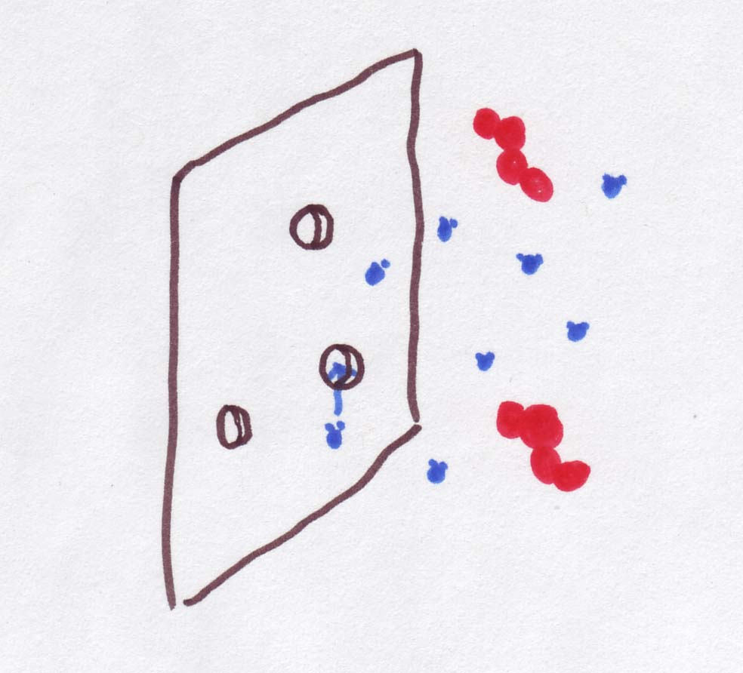
First we told you that diffusion through a membrane was just a special case of plain-vanilla diffusion -- we got to assume that there were only two compartments of interest (left and right), which simplified the math a lot.
Now, we're going to tell you that osmosis is a special case of diffusion through the membrane. And it's the membrane that makes it special. Recall that membranes vary in terms of their permeability. Some might be like the proverbial brick wall, while others might be 'leaky as a sieve'. But imagine a membrane with gaps* just big enough to let water through, but too small to let anything else across.
How is this a special case of diffusion through a membrane? Basically, what happens is that water can diffuse but nothing else in the water -- salt, sugar, or other solute -- can get through.
So, instead of general permeability of the membrane, what we care about now is permeability to water, or P_{H2O} .
Continuous version | 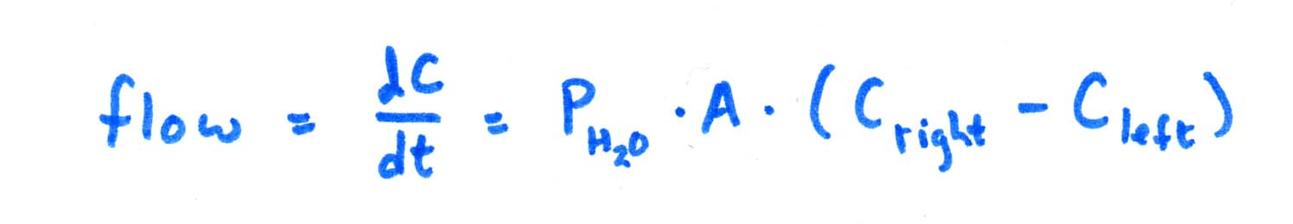
Discrete version | 
*more properly, permeability of the membrane has to do with selective gateways and polarity and so on, but imagining gaps in the membrane will work too.

Putting the "Os" into "Osmolarity"
We need to make one other change. So far we've used the molarity (moles of solute per liter) of solutions like sugar water as our way of measuring concentration. In truth, the measure of concentration that we need is not molarity, but osmolarity. Osmolarity is defined by osmoles of solute per liter (kind of like moles, but with an OS on the front). The abbreviation, which we'll use a lot, is OsM.
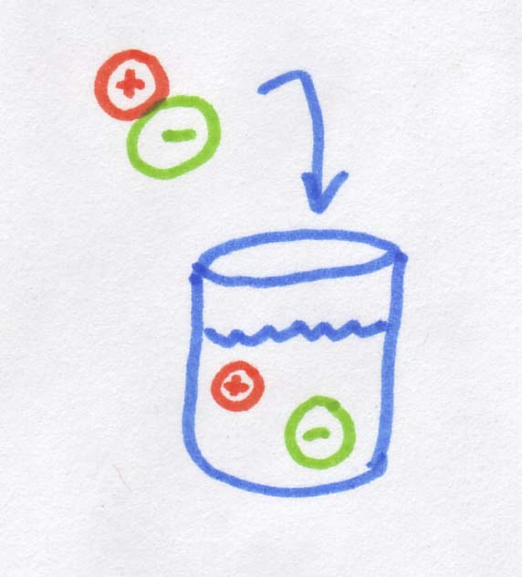
So what is an osmole? As you may know, when you dissolve salt in water, it disassociates into Na⁺ and Cl⁻, in other words, into two pieces. If 1 mole of molecules dissolves into two "pieces" it creates 2 osmoles. If we started with MgCl₂, which dissolves into 3 "pieces", we would get 3 osmoles. Sugar is an organic rather than ionic compound, so it does not disassociate, and 1 mole of sugar dissolves into 1 osmole.
So when we're talking about diffusion across a membrane (including osmosis), it doesn't actually matter that salt ions are smaller than sugar molecules, or that their molecular weight is less, or even that the ions are charged while the sugar molecules are electrically neutral. The only thing that actually matters is how many "pieces" the salt dissociates into. For every salt "molecule*" you dump into water, you get TWO ions rather than one, and this is what matters. Essentially a salt molecule provides twice as many "bits" of dissolved stuff as the sugar molecule, so the osmolarity is also doubled.

If I dissolve 2 moles of table salt (NaCl) in 1 litter of water, what osmolarity is produced?
- One molecule of salt makes 2 "bits" when dissolved
- 2 moles of salt will make 4 moles of "bits"

Answer: 4 moles of "bits" / 1L of water = 4 OsM

If I dissolve 4 moles of MgCl₂ in 2 L of water what will the osmolarity be?
- MgCl₂ dissolves into Mg²⁺ + 2Cl⁻ or 3 bits
- osmolarity is "bits" / litters

Answer: 4 moles MgCl₂ = 12 moles of "bits" 12 moles / 2L = 6 OsM

*Yes, I know that salt is an ionic compound and comes in the form of crystalline lattice. However, it is easier to think in terms of a salt "molecule"

Figuring osmolarity

If you know molarity

What is the osmolarity of a 2.6 M solution of table salt (NaCl)?
- Salt dissolves into 2 "bits".
- Read the section above again!

Answer: 2.6 M * 2 = 5.2 OsM
If you need to figure out the osmolarity of a solution and you're given the molar concentration, its pretty simple, just multiply the molarity by however many "pieces" the solute dissociates into.

If you know amount of solute
What if you just know the amount of a solute that was added? For example: what is the approximate osmolarity of a can of coca cola? According to the can which just happens to be sitting next to me, there are 37g of sugar in 12oz of classic coke. (Remember we've calculated before that sugar has a molecular weight of 180g). Hmm, time to crank out some conversions:
First, grams to moles: 37g * 1 mole/180g = 0.205 moles
Next, ounces to liters: 12 oz * 1 liter / 28.5 oz = 0.42 liters
Finally, we know that sugar does not break apart, so 1M = 1 OsM.
Now that everything is in the right units, we just need to divide moles by liters to get the osmolarity:
0.205 moles / 0.42 liters = 0.49 OsM.

What is the osmolarity of a glass of skim milk? (13g of lactose in 236 mL)
- Lactose is a kind of sugar and has a molecular weight of 180g per mole.
- 13g lactose * 1 mole/180g = 0.07 moles, which do not dissolve into smaller "pieces".

Answer: 0.07 moles / 0.236 litters = 0.31 OsM
Think about that next time you have a coke and a Krispy Kreme for breakfast!

It can take many solutes to make osmolarity
On the last screen, we calculated the osmolarity of a classic coke to be 0.49 OsM. That is not, however, exactly right. The reason is that sugar is not the only thing dissolved in that can. For example, there are also 35mg of salt. To calculate the total osmolarity, we also need to take the salt into account (as well as a bunch of other minor players like color and flavor molecules, but we'll stick with the salt for now).
In order to figure out how many moles of salt we have, we need to know the molecular weight. One mole of sodium weighs 23g, and one mole of chlorine weighs 35g. When the sodium and chlorine are combined in a single molecule, one mole of the stuff weighs 23 + 35 = 58g.
So, converting from mg to moles: 35 mg * 1 g / 1000 mg * 1 mole / 58g = 0.00060 moles
And we know that salt dissociates into one sodium ion and one chlorine ion (Na+ and Cl-), making TWO moles of ions. Or,
0.00060 undissolved moles --> 0.0012 moles of dissolved ions
And, remembering that the 12 ounces of coke was the same as 0.42 liters, the osmolarity associated with the salt is:
0.0012 osmoles / 0.42 liters = 0.0029 OsM
To get the total osmolarity of the coke, we add up the two osmolarities associated with each ingredient:
total osmolarity = 0.49 OsM + 0.0029 OsM = 0.4929 OsM.
Obviously we could keep going down the ingredient list, but probably you've got the idea by now.

What is the osmolarity of seawater given the following:
Solute | g / L | molecular weight
Cl⁻ | 19 | 35
Na⁺ | 10.5 | 23
Mg | 1.3 | 24
S | 0.8 | 32

- To convert grams to moles, multiply grams by 1 / molecular weight.
- Add all the molarity from first hint.

Answer: 19 * 1/35 + 10.5 * 1/23 + 1.3 *1/24 + .8 * 1/32
= 0.54 + 0.46 + 0.054 + 0.025
= 1.08 OsM = 1080 mOsM

Why does osmolarity matter?
Why does all this matter? Water has a tendency to move across a membrane from a lower osmolarity to a higher osmolarity. In other words, from the dilute side to the concentrated side. The outcome is that the dilute side loses water and becomes more concentrated, and the concentrated side gains water to become more dilute, so the two sides become more similar.
Osmolarity is 3 times higher on the right, but the red molecules are trapped over there. Instead, the water can move, so it goes TOWARDS the high-osmolarity side. That makes the left side more concentrated and the right side less concentrated | 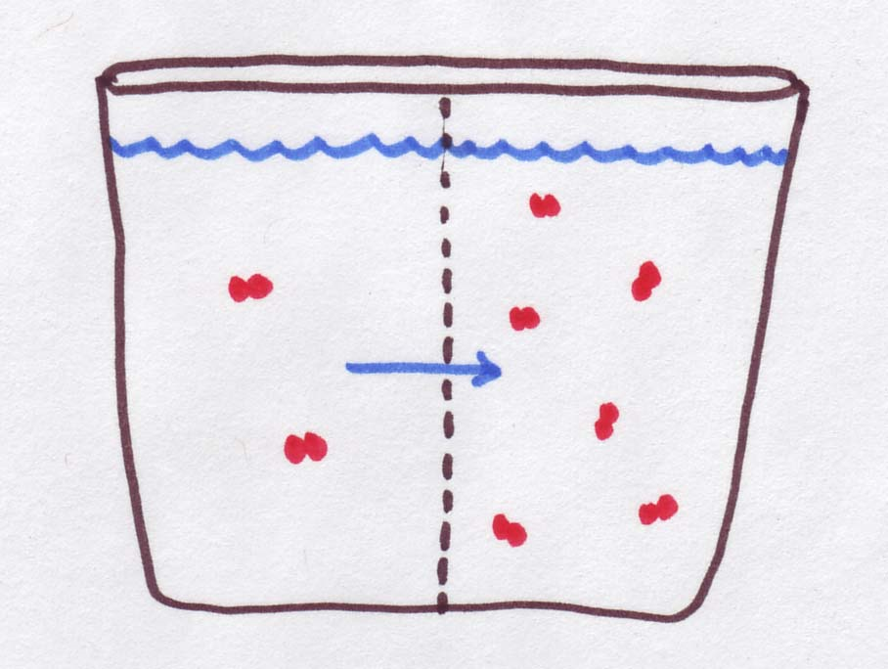
In the figure below, there are 3 solutions (0.2M, 0.5M, and 0.7M) separated by membranes. Your job is to figure out which direction(s) water is moving:
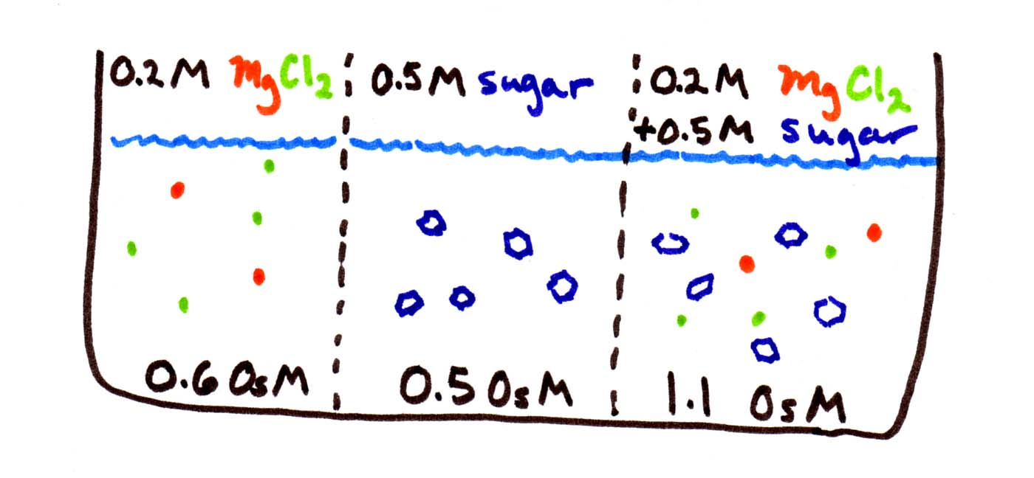
The first thing to be careful of is to calculate the osmolarities before you start. Since MgCl₂ disassociates into 3 pieces, its osmolarity is triple, i.e., 0.6 OsM. Sugar does not disassociate, so it stays at 0.5 OsM. The third solution contains both sets of solutes, so its osmolarity is 0.5+0.6 = 1.1 OsM.
Then remember that water goes from low to high osmolarity, from weak to concentrated solutions. You can think of it as water "trying" to equalize the concentrations. So water flows from the middle compartment to either side, since both have higher osmolarity.

How fast will osmosis occur?
We determined which way water flows, but shouldn't it go faster to the right (toward the very concentrated solution) than to the left (a solution that is barely different in concentration)? In fact this is true, and it is directly reflected in the equation for the 2-compartment model:
Continuous version
Discrete version
We don't know either the permeability (P_{water}) or the area of the membrane (A). But this doesn't really matter if we just want to know how the rates of flow compare. We do know how the concentration differences compare (C_{right} - C_{left} ). Between the first and second compartments, the difference in osmolarity is only 0.1 OsM. Between the second and third compartments, the difference in osmolarity is only 0.6 OsM. So water should flow 6 times faster to the right than to the left.
Of course this state of affairs only lasts for a split second. As soon as water starts to flow, the concentration differences change, and the relative rates of flow change. If you are using the continuous equation, the adjustments will be made immediately. If you are using the discrete version, the adjustment will only be made after Δt time has passed.

What else can the equations tell us?
Here are a few last questions on interpreting the equations:

What will the rate of water flow be if permeability is zero?
- Permeability is P_{water}.
- Zero times anything is zero.

Answer: No matter how high the difference in osmolarity, no osmosis will occur if the permeability is 0. For example, osmosis will not work through a brick wall

When will the rate of water flow be the highest?
- the product of three quantities is maximized when each quantity is maximized

Answer: First, you need the permeability to be as high as possible. Secondly, you need the difference in osmolarity to be as high as possible. So, if OsM A=0 (pure water) and OsM B was as high as possible, then the rate of water will be maximized

What happens if the osmolarity of the two solutions is the same?
- If the osmolarities are the same, what about the concentrations?

Answer: If OsM B = OsM A, then (OsM B - OsM A) = 0, so NO net osmosis will take place, no matter how large or leaky your membrane.

Where does it all end?
So, a quick recap. We can figure out which way water is flowing. And, using the iteration technique at the end of the section on diffusion through a membrane, we can figure out how much water is flowing at each time step (delta t). You may remember that we stopped figuring it out after 5 or 6 time steps because the rate of flow kept slowing down, so although we were getting to equilibrium, we were getting there slower and slower and s-l-o-w-e-r. It got boring.
However, there is still one more property of the system that we can figure out -- what happens at the end of that slower and slower process -- in other words, what are the equilibrium concentrations, and how much water is on either side of the membrane. And we can do this without endlessly pushing buttons on a calculator.
Let's use sugar as an example. Say we started with 0.2 moles of sugar in 1 liter of water on one side, and 0.8 moles of sugar in 1 liter of water on the other side. The water is free to move back and forth across the membrane, but the sugar's not going anywhere, and no extra sugar or water can move in or out of the 2-compartment system. So at the end of the day,
•there will still be 0.2 moles of sugar on one side and 0.8 on the other side,
•and there will still be 2 liters of water,
•and the concentrations on either side will be equal,
•BUT the water will not be equally distributed.

How can you find the final water levels using intuition?
- The final water level on the 0.8 mole side must be 4 times higher than on the 0.2 mole side.
- The total water level has to add up to 2 liters

Answer: 1.6 L+ 0.4 L fulfills these conditions

How can you find the final water levels using formal equations?
- the final molarities must be equal, so
0.2/W₁ = 0.8/W₂ , or
0.2 W₂ = 0.8 W₁ ,or
W₂ = 4 W₁
- The total amount of water is 2 L so W₁ + W₂ = 2

Answer: Substitute 4 W₁ for W₂, so W₁ + 4 W₁ = 2
5 W₁ = 2
W₁ = 0.4 L
W₂ = 2 - 0.4 = 1.6 L

Sharks and alligators and goldfish, oh my
So what, if anything, does all of this tell us about life-as-we-know-it? Here is one small example.
Below is a table of osmolarities associated with environments and organisms:
seawater: 1 OsM | freshwater: 0.001 OsM
shark: 1.075 OsM | goldfish: 0.293 OsM
 | alligator: 0.278 OsM
 | mammal: 0.330 OsM
So a shark is a little "saltier" than its environment, and a freshwater fish is a lot saltier (inside) than the water around it. Why?
Sharks do not generally "drink". Instead they get freshwater from the seawater around them. Because their insides are a little saltier than the water around them, freshwater flows INTO their cells from their surroundings. The opposite of what would happen to you or me, who would get pickled if we spent too long in the ocean...
On the other hand, mammals are a lot saltier than their environment. But when you drink water, your body fluids become more diluted, so water flows INTO your cells. That's why everyone wants you to drink 8-10 glasses a day of water. And by the same token, if you put a shark into freshwater, the results would NOT be pretty. (The difference in OsM between shark and freshwater is 1.074, vs. 0.292 for goldfish and freshwater.)

Review
Osmosis is a special case of diffusion in which only water moves across a membrane from dilute side (higher water concentration) to concentrated side (lower water concentration).
For osmosis, the measure of concentration changes from molarity to osmolarity. Osmolarity is defined by osmoles of solute per liter of solution e.g. 1 mol/L solution of KCl has molarity (M) of 1 but its osmolarity (OsM) is 2 because KCl creates 2 osmoles by dissolving into K⁺ and Cl⁻. But 1M solution of glucose has osmolarity of 1OsM because glucose is not an ionic compound and it does not dissolve into smaller pieces.
Osmolarity of a solution is given by adding the osmoles of all the solutes present in the solution.
During osmosis, the rate of flow of water across the membrane depends on number of factors including permeability of membrane to water, area of membrane and concentration difference between two sides. These factors are summed up in the equation:
flow = P_{water} * A * ΔC
So, if ΔC is doubled flow of water would double and so on.
Eventually equilibrium is reached when concentrations on both sides are the same but under equilibrium conditions amount of water on both sides will not be equal.

