
Visualization:

Log Transformations

URL: http://mathbench.umd.edu/modules/visualization_log-transformations/page01.htm

Note: All printer-friendly versions of the modules use an amazing new interactive technique called “cover up the answers”. You know what to do…

Logs of graphs and Graphs of logs
In this module we're going to discuss ways of combining logs and graphics. You remember logs, right? Just in case you don't, here are 2 pictures of logs again:
A size 5 log  Log(100,000) = 5 | A size 9 log  Log(1,000,000, 000) = 9
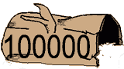 | 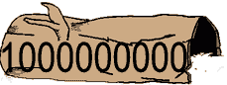
Remember that the log of the measurement basically tells you how much space that number takes up.
If the measurement is bigger than one, it "takes up space" in front of the decimal and the log is positive. A 6-digit number has a log of 5-point-something. A 10-digit number has a log of 9-point-something.
If the measurement is smaller than one, it only "takes up space" AFTER the decimal point, and the log is negative.
A measurement of zero doesn't take up any space before OR after the decimal point, and it has no log. Neither does a negative measurement. That's okay, because usually we're using logs to measure things size, weight, height, or the number of organisms in a population. These measurements can't be negative in any case.
It's all very well to take logs of individual numbers, but what we really want is to be able to visualize these numbers in relation to other numbers. Therefore we need to make graphs. There are two ways you can do this.
- Take the log of each number, and then make a normal graph.
- Make a graph, and let the paper "take the log" of the number.

Method 1: Log, then graph.
Assuming you have a calculator, it's pretty easy to take the log of each number and then make a graph on normal graph paper. (It might take some time, but that's your problem, right?).
Here's an example. First, just show you the normal graph. No logs involved here. Nothing up my sleeve, either.
time (hrs) | 12 | 24 | 36 | 48 | 60
# bacteria | 10 | 100 | 1,000 | 10,000 | 100,000
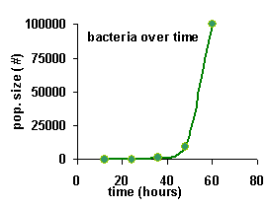
There is problem with this graph -- the y values (number of bacteria) are in the bottom 10% of the graph, except for the very last value. Because the last value is 10 times bigger than any of the other values, the other values all get squished.
But, you should notice something interesting about the data. Every hour, the number of bacteria increases by a factor of 10. That is, the number of bacteria multiply. So, what we need is a multiplicative scale. And that's what logs are. The log tells you how many places the number takes up -- in other words, how many times the number has been multiplied by 10.
So, let's try the same graph, but take the logs of the data first. Once again, if you want to play along at home, yet your calculator, find the logs, and make the graph. Or, just click on the button.
time (hrs) | 12 | 24 | 36 | 48 | 60
# bacteria | 10 | 100 | 1,000 | 10,000 | 100,000
log (# bacteria) | 1 | 2 | 3 | 4 | 5
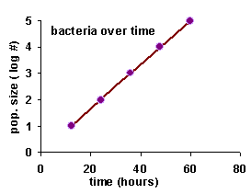

The curvy line turned into a straight line!
You probably noticed the curvy line on the original graph turned into a straight line on the log transformed graph.
Why does this happen? Consider the following 2 facts:
1. As you increase a log by 1, you're increasing the magnitude of the original measurement by a factor of 10.
2. When you allow an additional unit of time to go by (in this case, half a day), you're allowing the bacteria to increase by a factor of 10.
So, taking the log accounts for the multiplying nature of bacterial growth, and all you're left with on the graph is a straight line, pointing upwards.
When growth happens by multiplying the population by a constant number each timestep, we call that exponential growth. And any time you have exponential growth, taking the log of the population size will turn the graph into a straight line. Even if the constant multiplier is not 10 -- in which case your straight line will have a different slope, but it will still be straight.

To transform or not to transform?
That doesn't mean that all curvy lines become straight lines if you log-transform the data. The straightening effect only occurs if the original graph involves exponential growth -- that is, growth with the constant multiplier. Or exponential "de-growth" (decay).
Nevertheless, many kinds of graphs to become "un-squished" when you log transform the data. Transforming the data can be especially useful when there are big differences in the magnitudes of the numbers you're working with. If most of your numbers are fairly small, but there are a few very large numbers, he can really help to log-transform the data.
Remember, logs are all about orders of magnitude. So, if your data differs by a couple orders of magnitude or more, then you might want to think about log-transforming it.

Method 2: graph, then log.
In the first method, you transform first, then graph. In the second method, you graph first -- then let the graph paper do all the hard work. You just have to use a special graph paper with a log scale.
There are two kinds of log graph paper.
• Semi-log paper as a log scale only on the y-axis.
• Log-log paper has a log scale on both the x and the y-axes.
In the example we've been using so far, we want to take the log of the data on the y-axis, but the data on x-axis is fine the way it is. Therefore, we want to use semi-log paper.
Semi-log paper is a little mysterious at first. Here is a small piece:
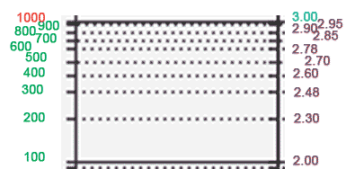
This is called a "cycle, " and in this case it goes from 100 to 1000. The cycle is always divided into 10 pieces, as shown on the left (100 - 200 - 300 - 400 ... ). I'm sure you've noticed that the lines get closer together at the top of the cycle -- that's because the numbers are arranged on a log scale. The number half-way between 100 and 1000 is NOT 550, as on an ordinary scale, but rather (approximately) 300.
On the right, I'm showing you how the measurements on the left correspond to their logged values on the right -- normally these purple numbers are NOT written on the graph. However, I'm doing it so that you can see that the LOGGED numbers proceed in an orderly fashion, with 2.48 being just about in the middle between 2 and 3.
So, to plot a number like 420, you have to
• count up by hundreds to get to 400, then
• fudge a little to get 420.

Graphing bigger (and smaller) numbers
You can stack several cycles to get paper that spans several orders of magnitude (every time you multiply by 10, you get 1 order of magnitude). Here are two possibilities.
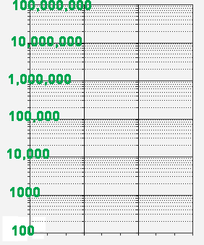 | 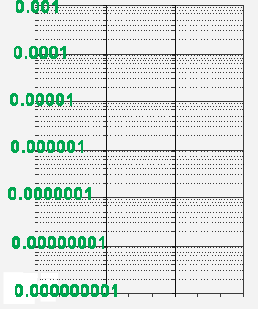

How many cycles would you need to represent the following data:

year | 1990 | 1991 | 1992 | 1993 | 1994 | 1995 | 1996 | 1997 | 1998
popn. size | 3 | 17 | 190 | 2871 | 6743 | 34 | 590 | 4282 | 38,475

- What are the min and max measurements?
- The min and max are 3 and 38,475 -- what is the approximate log of each measurement?
- The data span 5 orders of magnitude?
- The log of the smallest populuation size is 1-point-something, and the log of the largest population size is 6-point-something. That means you'll need cycles 1 through 5 -- 5 cycles altogether. The first cycle will be labelled "1", and the last cycle will be labelled "10,000".

Answer: 5 cycles, labelled "1" through "10,000".

How many cycles would you need to represent the following data:

day | 1990 | 1991 | 1992 | 1993 | 1994 | 1995 | 1996 | 1997 | 1998
cell size (um) | 0.003 | 0.017 | 0.290 | 0.2871 | 6.743 | 34.0 | 0.590 | 0.04282 | 3.8475

- What are the min and max measurements?
- The min and max are 0.003 and 34.0 -- what is the approximate log of each measurement?
- The smallest cycle must start with 0.001. The largest cycle must start with 10.0.
- The smallest cycle must start with 0.001, and the largest cycle with 10.0. That means 5 cycles.

Answer: 5 cycles, labelled "0.001" through "10".

Try it out
The following table contains data on human population growth over the last 3000 years. Above, this data is plotted on a normal graph. Because the data spans many orders of magnitude, the graph looks kinda empty. This is a good candidate for log transformation -- can you correctly place each point on the semi-log paper below?

year | 1000 BC | 0 AD | 1000 | 1400 | 1750 | 1850 | 1950 | 1970 | 1980 | 1990 | 2007
popn. size (millions) | 50 | 200 | 300 | 220 | 790 | 1260 | 2520 | 3690 | 4430 | 5260 | 6600

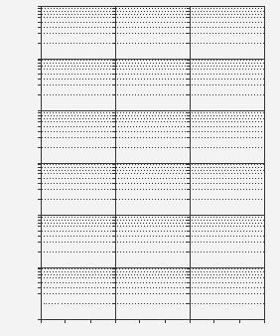

Just add realism
Here is one last dataset. This data represents the biomass of bacteria growing in a medium. At first there are virtually unlimited resources, and the bacteria multiplies at a constant rate. Later, when the bacteria reach the limit of the resources, there is a period of steady population size. Finally the population declines as resources are exhausted.
Week | 1 | 2 | 3 | 4 | 5 | 6 | 7 | 8 | 9
Popn. size | 0.1 | 1.8 | 32.4 | 583 | 500 | 600 | 35 | 2 | 0.12
So, both the left side of the graph is a straight line heading up -- because the bacteria are growing exponentially, i.e., multiplying by a constant fact. And the right side of the graph is a straight line heading down -- because the bacteria are dying off exponentially, i.e., each timestep there is a constant fraction of the number there were the timestep before. These straight lines are diagnostic of exponential growth and exponential decay.

Review
If your data differs by a couple orders of magnitude or more, then an ordinary graph will make your data look "squished", and you might want to think about a log-transformation. There are two ways you can do this.
- Take the log of each number, and then make a normal graph.
- Make a graph, and let the paper "take the log" of the number.
In either case your graph will have the same shape.
As an added bonus, IF your data represents an exponential growth or decay process, THEN log-transforming it will turn the graph into a straight line. (The slope of the line will even give you a hint as to the rate of the exponential growth or decay, although we didn't get into this.)
Semi-log paper is tricky to use at first. It is divided into "cycles," which are themselves divided into 10 pieces. The lines get closer together at the top of the cycle, because the numbers are arranged on a log scale. Each cycle starts at a multiple of ten, and its NOT possible to get to zero.

