

Cell Processes:

Diffusion through a membrane

URL: http://mathbench.umd.edu/modules-au/cell-processes_diffmembrane/page01.htm

In the Module on Diffusion we looked at diffusion of a substance through air or fluid. In biological systems the membrane provides a barrier around the cell so we need to look at diffusion through cell membranes.

Learning Outcomes
After completing this module you should be able to:

- Apply the diffusion equations to movement of a substance across a membrane, which is selectively permeable.

Equation déjà vu
Remember back in the diffusion module, we used an equation to relate the rate of diffusion (rate of flow of particles through and area, i.e. flux) to the steepness of the concentration gradient? Well, in case you’ve forgotten, that equation was:
Continuous form
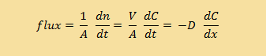
and we also discussed how this “continuous” equation can be made into a “discrete” equation:

Discrete form

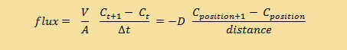

In these equations, n is the number of particles, t is the time, C is the concentration, V is the volume, A is the area through which the particles are diffusing, D is the diffusion coefficient and dC/dx (or ΔC/Δx ) is the gradient.

It is important to understand that BOTH of these equations refer to the same basic phenomenon – particles moving at random, with the net result that particles move from areas of high concentration to areas of low concentration. BOTH of these equations describe what’s happening in the same way – the concentration gradient is defined by the difference in concentrations per distance between them. Remember that the units of flux are mol m⁻² s⁻¹.
So why are we using two different equations for the same thing??? Sometimes, a discrete equation is an "easier" version of a continuous equation, and sometimes it's the other way around, the continuous is an "easier" version of the discrete. In this case, the discrete is easier, but the continuous is more realistic. The discrete is an approximation or simplification of reality. The discrete equation tells us a lot about the process without needing to get involved in the truly messy kind of maths required to work with the continuous version (which require partial differential equations -- look them up if you want to know more!).

Simplifying the situation
But first, back to biology. We're going to talk about what happens when you have a concentrated solution (think sugar water) and a less concentrated solution (think distilled water). Here are the equations again:
Continuous form

Discrete form

Remember that in the diffusion module, we were talking about the diffusion happening in a sort of imaginary tube, like this:
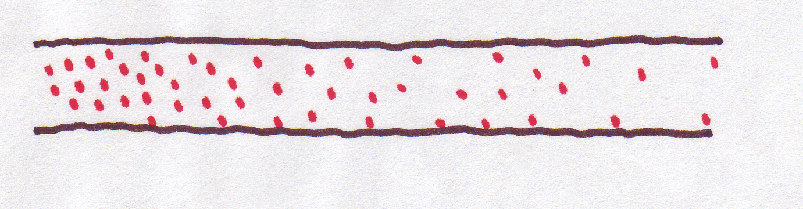
That's why we talked about concentration at "positions" along the tube. But in this module, we simplify the situation: just two sides of membrane -- inside and outside, or left and right (or the right side and the wrong side of the tracks, or however else you want to think about it). Politics aside, right and left is a lot easier to deal with than a spectrum of possible positions.
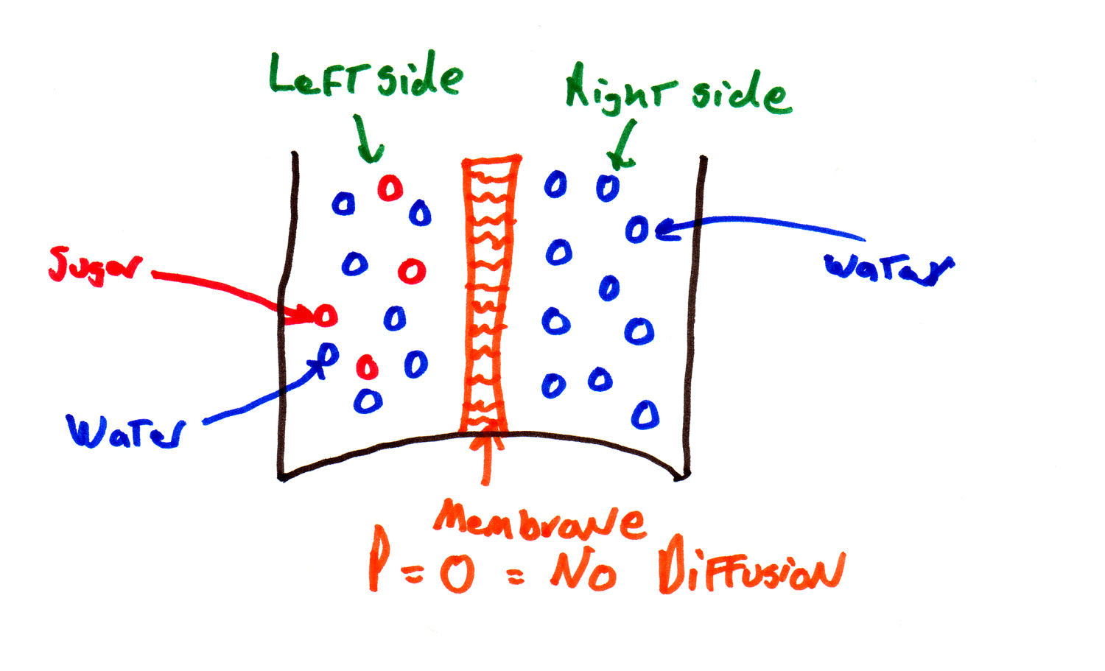
Here are a couple of other assumptions we need to make about the state of the system (think of this as the legal fine print):
1. The solutions on both sides of the membrane are homogeneous. By this we mean that the solute is evenly mixed so there is no active diffusion taking place within a side.

2. The membrane is not changing width, so the distance between the sides is a constant.
This is called the "two compartment model" -- the continuous positions in the original equations are replaced by two compartments, and this is going to make the equations easier to deal with.

What does continuous mean?
Continuous form: | 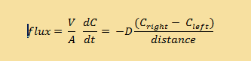
Discrete form: | 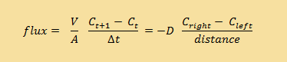

Notice that we replaced the "position+1" and "position" subscripts with "right" and "left", but we haven't changed anything else (yet).
First, SO WHAT DOES CONTINUOUS MEAN ANYWAY?
The old "continuous" equation was continuous over both space (the positions in the tube idea) and time (the rate of diffusion changed gradually).
The new continuous equation will be continuous in time only. It is not continuous in space because we now have only two compartments.
The "discrete" equation is even easier -- it is not continuous in space (remember the 2-compartment model) OR time (the rate of diffusion stays the same for whatever time interval you specify). For example, if you use the discrete equation with one second time intervals, the rate only gets recalculated every second, and the graph looks "blocky". This is OK because the rate isn't changing very fast. If it was, the discrete equations which only calculate the rate every one second, might seriously mis-estimate the situation.
We'll continue to develop the equations in both continuous and discrete form, and at the very end of the module, we'll compare their performance.

Thinking about permeability
So far, we've changed the equations to account for the left and the right side of the model, but we still haven't thought about what's in between -- the membrane. Right now, there's a "diffusion coefficient" (D) in there, but what we need is a number to characterise the membrane.
How much solution will flow through the membrane depends on how permeable the membrane is. Some membranes are very leaky, some only let through certain molecules, and some let through virtually nothing.
For instance if the membrane was made of cling wrap, it would block all diffusion -- cling wrap is not permeable:
 | ←  Membrane is totally impermeable to anything  →
If the membrane was made of window screening, it wouldn't block anything – it’s completely permeable.
 | ←  Membrane is  completely permeable  → | 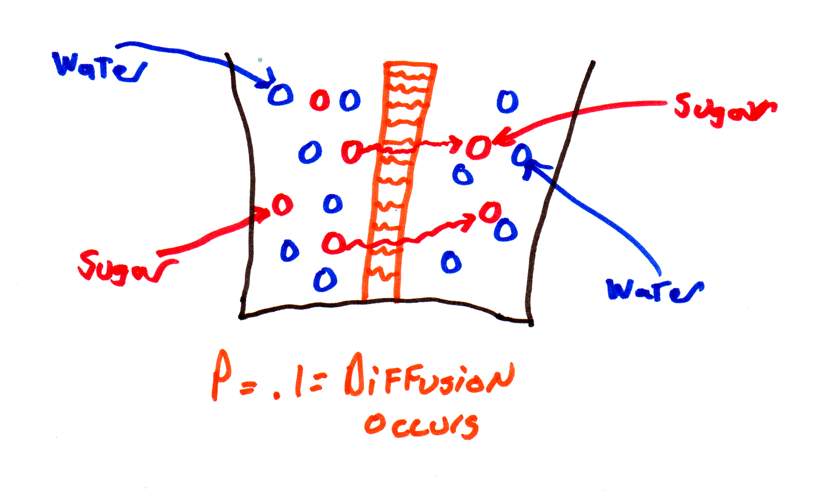
Presumably you could find some substance that was midway between cling wrap and window screening -- something that was partially permeable. This suggests that with a small adaptation, we could continue to use our old diffusion equations (mathematicians LOVE recycling their equations). We could change the diffusion coefficient D into something that accounts for the permeability of the membrane. Let's call that .... P (easy to remember).

Getting personal with P
What is this new measure P and how does it relate to what we had before????
We want to know how much of our sugar is crossing the proverbial border and going into the other side of the membrane. So permeability (P) is going to depend upon 3 things:
1. P depends in part on D (the diffusion coefficient), which is determined by the size of the particle diffusing and the solution being diffused through. All else being equal, particles with a higher diffusion coefficient also have a higher permeability.
--> P increases when D increases.
2. P also depends on the width of the membrane. All else being equal, permeability is higher when the membrane is thinner. (Thus P takes care of the dx or Δx that was in the old diffusion equation).
--> P decreases when Δx increases.
3. Finally, there is a term we can measure and come up with experimentally, called K. Molecules that are "slippery", like lipids, have a high value of K, while charged particles (like the ions from salt) have a low value of K. And K can vary over a huge range, much more so than either P or Δx or D.
Another name for K is the partition coefficient, which is the ratio of the solubility of the molecule in lipid and water. Because the cell membrane interior is made up of hydrophobic fatty acid tails, substances that are hydrophobic will pass through easily, while hydrophilic substances such as amino acids and ions will go through very, very slowly.

--> P increases when K increases.
So now we have a new measurement which is important for diffusion through a membrane P which is.....
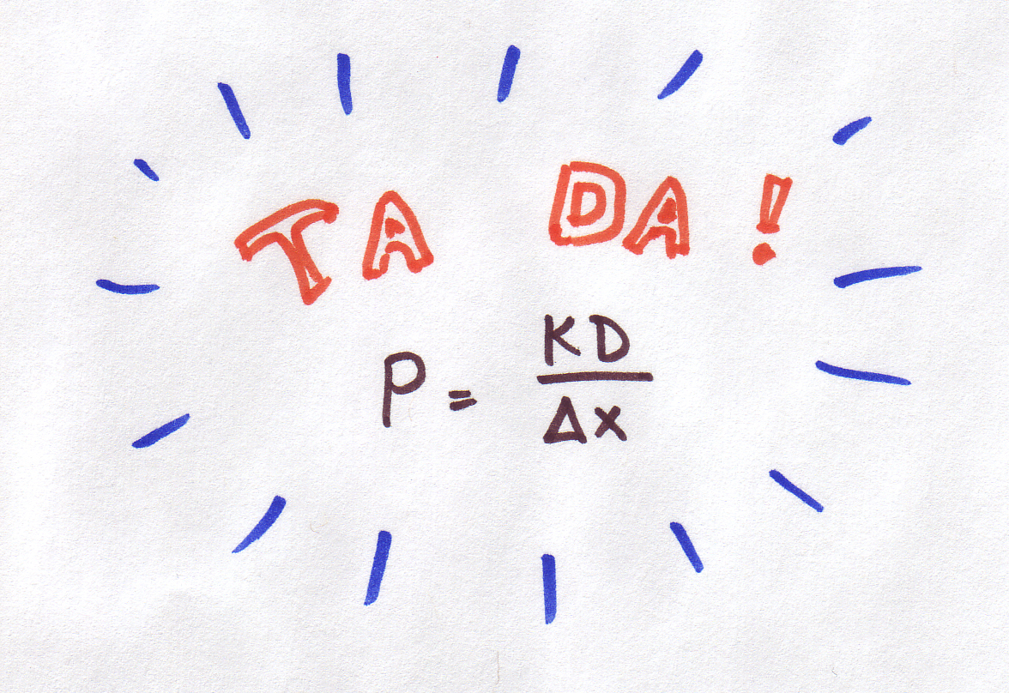
This is the important quantity which will now stand in for just plain old D in our diffusion equations above. (The units of P are cm/sec or cm s ⁻¹).

Assume that the diffusion coefficient (D) is 1 x 10⁻⁶ cm²/sec at 10ºC, and that the membrane is 1 mm wide (0.1 cm), K=0.004. What is P equal to?
- Plugging these numbers into the equation P = ^{kD} / _{∆x}
- P = 0.004 * 10 ⁻⁶ / 0.1

Answer: P = 4 * 10⁻⁸ ^{cm}/_{sec}
In nature, the permeability constant is normally very small, usually around 0.00005, although it can be as high as 4. Notice that it’s important that you get all the units to match before you do the calculations. For example, if we hadn't converted 1 mm to 0.1 cm, the permeabilities would have been 10 times too high.

The area of the membrane matters
One more thing, before we get too enthusiastic about our new equations. We can imagine a litre of salt water and a litre of distilled water with a membrane (the partially permeable kind) between them, and we know that the thickness of the membrane is taken care of as a part of P ... but how wide and how tall is the membrane?? It will make a big difference if the membrane is 1 square centimetre or 1 square metre in area!! In fact, I would be willing to take bets that if the membrane has 10 times the area, it will let 10 times more stuff through (that would be a linear relationship).
This issue becomes pretty important when we start thinking about scaling and things like the surface area of the lungs.
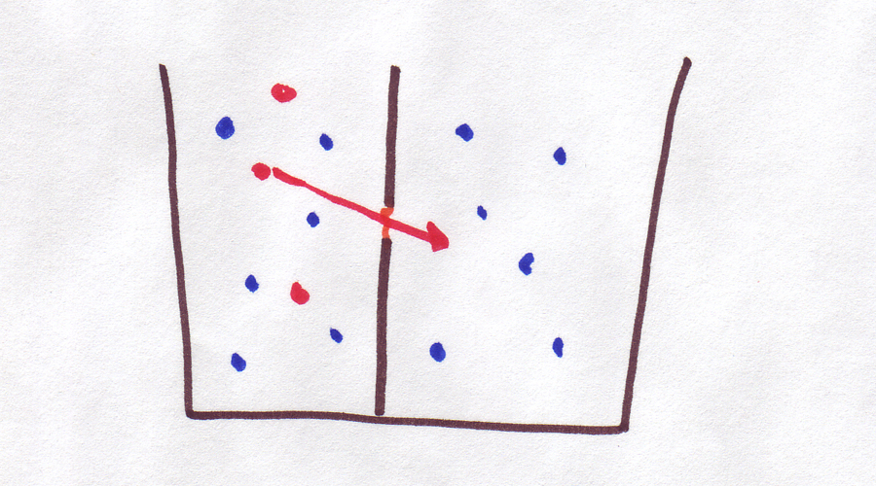 | ←Small Membrane to left  Large Membrane on right → | 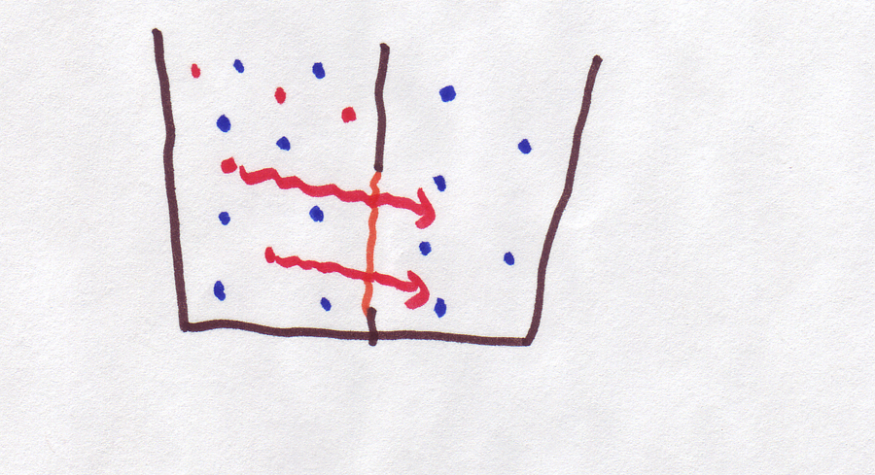

Our equations are ready
You will recall from the diffusion module that flux is equal to the flow multiplied by the area (A) through which the substance is flowing. If we multiply the flux equations by A and use our new expression for the permeability P, in place of D, we can express the flow as:
Continuous  version | 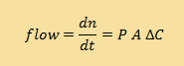
Discrete  version | 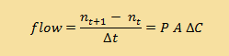

We can also express flux (flow rate divided by the area) in terms of the permeability and the difference in concentration between both sides:
flux = P ΔC
In the case of diffusion through a membrane then, flux is equal to the permeability multiplied by the difference in concentrations on either side. In order to do any calculations, we will have to get a handle on the actual values of these variables.
That means we need to be able to measure concentration. You might think this is pretty easy. For example, if you put 100 grams of sugar in a total volume of 1L of water, you will have a solution that is 10% sugar by weight, and you probably don't want to try to drink it. (Honest, even Red Bull is only about 9% by weight).
However, unfortunately, diffusion doesn't care about weight, it cares (if a process can be said to care) about particles. How many particles of sugar were in that 100 grams?
Before you get out a magnifying glass and start counting sugar grains, let's be clear about what a particle is: as a first approximation, a particle is a molecule. So, you need to know the molecular weight of sugar C₁₂H₂₂O₁₁, which is 342g. Thus 100g of sugar is 0.29 moles and the concentration is 0.29M
If you need a refresher on how to calculate molecular weight and molarity, you should revise the module on this topic.

And what you've all been waiting for
Using the equation governing the flow of sugar across a membrane, and given that:
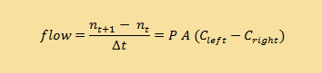
The area of the membrane between the two solutions is 2 cm²
The concentration of the solution on the left side of the membrane = 0.4M
The concentration of the solution on the right side of the membrane = 0.1M and
P= 0.02 cm/sec
What is the rate of diffusion (flow rate) across the membrane for the following concentrations? This kind of problem requires straightforward substitution…
0.02cm/sec x 2 cm² x (0.4M sugar - 0.1M sugar) = 0.012 moles/second
The flux (flow rate/Area) would therefore be 0.012/2 = 0.006 mol cm ⁻² s ⁻¹
What would happen if we doubled the permeability constant? | the flux would double
What if we doubled the area of the membrane? | the flux would double
What if we doubled the concentration on the left? | the flux would NOT double. Instead, the difference between the left and right sides would increase from 0.3 to 0.7, so the flux would slightly more than double.

A metaphor for discrete and continuous

And now for the extended example comparing continuous and discrete equations.

Here is a metaphor for continuous and discrete equations: Imagine you are driving down a country road in outback Queensland -- the road is mostly flat, straight, and empty. You are doing all the things you learned in driver education: continually checking the road and your mirrors. You compensate immediately for any change in driving conditions. You are operating in a continuous mode.

However, you start to get bored. So, seeing as the road is nice and straight, you decide to catch up on some reading. Here's the new strategy: glance at the road to make sure you're headed in the right direction, look down at your book for 5 seconds. Glance up at the road again to readjust. Read for 5 more seconds, and so on. You're in discrete (or discontinuous) mode, and everything's peachy. Your Δt, the amount of time between readjustments, is 5 seconds, as opposed to when you were continuously checking the road and your Δt was infinitely small (called dt).

But in a surprising geographic twist, suddenly the road becomes twisty, with cliffs on one side. And suddenly, your DISCRETE strategy of glancing at the road every 5 seconds doesn't seem like a great idea. You might glance up just before a curve and make a sharp right, but you don't see the following sharp left and go sailing off the cliff. Or you might glance up and see a straight patch ahead but fail to notice the sharp right ahead, so you go smashing into a wall of rock. In any case, you'd better decrease your Δt (look up more often) or better yet, go back to continuous mode!

Continuous curves
In the same way, a continuous equation constantly "checks" its variables to see in which direction it should be heading (on a graph, rather than a road). A discrete equation only checks every once in a while, every Δt to be specific.
Here is a graph of the solution to the continuous model:
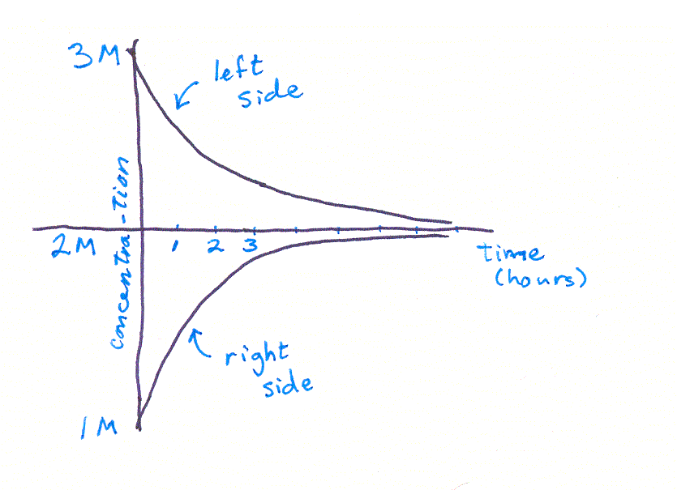
This graph shows the concentration of particles on the left and right sides of a membrane. At the beginning there are way more particles on the left, so the curves are far apart. Towards the end of the time, the compartments have a similar number of particles, so the curves are close together.
As we've said before, how fast the particles change places depends on how different the two compartments are, in other words, how far apart the two curves are. When the curves are far apart, the rate of change is fast and the curves are steep.
And, since we are graphing a solution to the CONTINUOUS equation, it is as if, at each miniscule timestep, we recalculate the concentrations in each compartment and readjust the slope. So the curves are nice and smooth.

Discrete curves
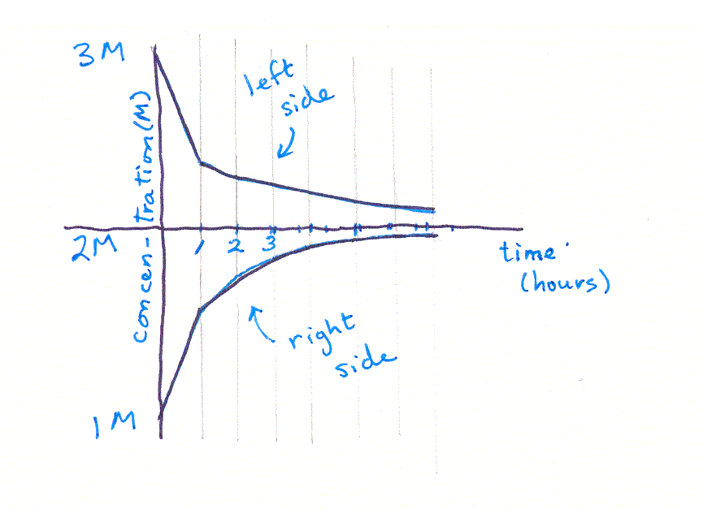
When we use the discrete equation, how fast the particles move still depends on how different the compartments are, but (and this is the important part) we only calculate the concentrations every once in a while, maybe every hour (so Δt = 1 hour). Then we assume they continue to cross the membrane at that rate, for an entire hour. This gives us a straight line segment (like driving your car in a straight line because you're not adjusting the steering wheel) which is a little steeper than it would be in the continuous version of the graph (like heading into a sharp turn and not readjusting the steering wheel).
At t = 1 hour, we recalculate how many particles are on each side and how fast they will move across the membrane. Likewise at t = 2 hours. And t = 3 hours. And so on.
Notice that this curve looks "segmented" or jerky, especially when it is steep. Like the twisty road, when things are changing fast, the discrete equation will not approximate the path well.

Iterating the discrete curve
We compared the shape of the curves given by the two models. Solving the continuous model here is beyond the scope of this module (that would get into a lot of calculus), but we can do the discrete model with a modest amount of algebra.
Let's go back to sugar water, with the following assumptions:
  - Initial concentration on left = 1 M
  - Initial concentration on right = 0 M
  - P = 0.1 cm/sec
  - A = 1 cm²
  - Equal volumes on both sides of membrane


We want to know what the final concentrations will be over time, i.e. at time 1 sec, 2 sec, 3 sec, 4 sec....... So let’s set up our equation from above. We know that:
Δn/Δt = 0.1 cm/sec x 1 cm² x (1M - 0M) = 0.1 moles/sec
So in the first second, approximately 0.1 moles change sides (from the more concentrated to the less concentrated side). That leaves
on the left side: 1 moles - 0.1 moles= 0.9 moles/liter
on the right side: 0 moles + 0.1 moles= 0.1 moles/litre
How about the concentrations at time 2 seconds? We need to readjust our estimate of diffusion rate by plugging in the new concentrations. Everything else stays the same:
Δn/Δt = .1 cm/sec x 1 cm² x (.9M - .1M) = .08 moles/sec
and the new concentrations are 0.82 and 0.18M.
on the left side: 0.9 moles - 0.08 moles= 0.82 moles/litre
on the right side: 0.1 moles + 0.08 moles= 0.18 moles/litre
Continuing on like this,
Δn/Δt at 3 seconds = 0.074 moles/sec,
C on left = 0.746 M, C on right = 0.254 M
Δn/Δt t at 4 seconds = 0.049 moles/sec,
C on left = 0.697 M, C on right = 0.303 M
Δn/Δt t at 5 seconds = 0.039 moles/sec,
C on left = 0.658 M, C on right = 0.342 M
Δn/Δt at 6 seconds = 0.032 moles/sec,
C on left = 0.626 M, C on right = 0.374M
This process is called "iteration" -- you iterate, or repeat, the equation over and over, each time substituting in the values calculated in the last iteration. You can see that, if we continued iterating long enough, we would eventually reach a point where the two concentrations were equal -- in other words, an equilibrium. (It would take a long time though, better use a spreadsheet rather than a calculator!) If you graph the two sets of concentrations, you'll see something like this:

Summary
The "diffusion through a membrane" equations: diffusion is driven by the difference in concentrations on the two sides of the membrane. It is also affected by the permeability coefficient and the area of the membrane:
Continuous version |  | 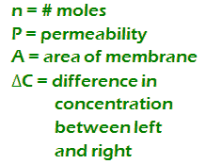
Discrete version

The permeability coefficient is determined by the equation P = KD/Δx.

A continuous equation constantly checks its direction so its graph has no breaks.
A discrete equation checks its direction at each Δt. A discrete curve may contain breaks.
In a discrete model, rate of flow across membrane is calculated at each Δt through a process of iteration (repeating the last step by substituting the values calculated from the last step) until equilibrium (when concentrations on both sides of the membrane are the same) is reached.
Iteration of a discrete curve yields a graph that is very similar to a continuous curve.

Learning Outcomes

You should now be able to apply the diffusion equations to determine which way a substance moves across a membrane that is selectively permeable.

